Validation — Quantitative Finance
Backtests, Out-of-Sample Testing, Multiple Testing and Model Risk: How Do We Know It Works?
From Train/Test Splits to Purged Cross-Validation, Deflated Sharpe Ratios and Model Governance
A companion module in the Quantitative Finance Curriculum — beginner to advanced
Covers: why models fail · in-sample versus out-of-sample · walk-forward testing · purging and embargo · combinatorial purged cross-validation · bootstrap confidence intervals · backtest biases · transaction costs and capacity · multiple testing and false discovery rate · deflated Sharpe ratio · information criteria and regularisation · parameter stability · VaR backtesting (Kupiec, Christoffersen, Basel traffic light) · expected shortfall · PIT calibration · pricing-model verification · Monte Carlo error · forecast evaluation and Brier score · information coefficient · permutation tests · stress testing · drift (PSI) · CUSUM monitoring · model-risk governance
Table of Contents
How to Use This Guide
What You Need to Know Before Starting
Understand Before Proceeding
Why It Matters
How This Connects to the Rest of the Curriculum
Glossary of Recurring Terms
Part 1 — Foundations: What Validation Is and Why Models Fail
1.1 Validation, Verification, Backtesting and Monitoring
1.2 How Financial Models Fail
1.3 Generalisation: Fit Is Not Forecast
1.4 The Signal-to-Noise Problem: A Lesson from Random Strategies
Part 2 — Data Splitting and Resampling for Time Series
2.1 Training, Validation and Test Sets
2.2 Walk-Forward Testing
2.3 Why Ordinary Cross-Validation Leaks, and How Purging Fixes It
2.4 Combinatorial Purged Cross-Validation (Awareness)
2.5 The Bootstrap: Putting Error Bars on Performance
Part 3 — Backtesting Trading Strategies
3.1 Anatomy of a Backtest
3.2 The Biases That Corrupt a Backtest
3.3 Transaction Costs, Slippage and Capacity
3.4 Performance Metrics and Their Uncertainty
Part 4 — Statistical Significance and Multiple Testing
4.1 Testing a Strategy's Mean Return
4.2 The Multiple-Testing Problem
4.3 Selection Bias and the Deflated Sharpe Ratio
4.4 Reality Checks and Backtest Overfitting (Awareness)
Part 5 — Overfitting Control and Model Selection
5.1 Penalising Complexity: Information Criteria
5.2 Hyperparameter Tuning and Nested Validation
5.3 Leakage in the Feature Pipeline
5.4 Parameter Stability and Sensitivity Analysis
5.5 Parsimony, Economic Rationale and the Degrees-of-Freedom Budget
Part 6 — Validating Risk Models: VaR, Expected Shortfall and Calibration
6.1 What a VaR Backtest Tests
6.2 The Basel Traffic Light and the Kupiec Test
6.3 Independence and Conditional Coverage
6.4 Expected Shortfall and Tail Validation
6.5 Validating a Whole Distribution: The Probability Integral Transform
Part 7 — Validating Pricing, Simulation and Forecasting Models
7.1 Verification: Is the Code Doing What the Specification Says?
7.2 Numerical Error: Simulation Noise and Discretisation
7.3 Calibration and Hedging Tests
7.4 Evaluating Forecasts: Loss Functions and Tests
7.5 Probability Forecasts and Calibration
Part 8 — Signal Validation, Robustness, Stress Tests and Drift
8.1 Information Coefficient and Quantile Analysis
8.2 Permutation and Reshuffling Tests
8.3 Robustness Across Sub-Periods, Regimes and Markets
8.4 Stress Tests and Scenario Analysis
8.5 Detecting Drift: Has the World Changed Since the Model Was Built?
Part 9 — Live Validation, Monitoring and Model-Risk Governance
9.1 Incubation, Paper Trading and the Capital Ramp
9.2 Statistical Monitoring and Kill-Switches
9.3 Model-Risk Governance
9.4 Reproducibility, Engineering Controls and Sanity Tests
Practical Exercise
Suggested approach
Common Beginner Mistakes
Advanced Extensions
Professional Applications
Where to Go Next
Appendix A — Formula Sheet
Appendix B — Self-Check Questions

How to Use This Guide
This document is a companion to Validation — Quantitative Finance, the module that asks the question every other module leaves open: how do we know it works? The Research module produces signals, Optimisation turns them into portfolios, Macroeconomics supplies regimes and risk premia, and Risk Metrics measures the downside. Validation is the discipline of testing all of those outputs honestly, before capital is exposed and while it is.
The guide is written to be read from beginner to advanced. It starts with why financial models fail and what 'out-of-sample' really means, and builds through walk-forward and purged cross-validation, backtesting biases, multiple-testing corrections and the deflated Sharpe ratio, to VaR backtesting, pricing-model checks, forecast evaluation, live monitoring, and model-risk governance. Each idea is introduced from first principles, paired with a worked numerical example, and illustrated with a chart or diagram. Every numbered section carries a level tag.
Table 0.1 — Suggested learning paths
If you are… | Read | Skim or skip
New to quant research | Parts 1–3 fully; Part 4 (4.1–4.2); Common Beginner Mistakes | Intermediate and Advanced tagged sections on a first pass
A strategy researcher | Parts 2, 3, 4, 5 and 9; the Practical Exercise | Parts 6–7 unless you also run risk or pricing models
A risk or model-validation analyst | Parts 1, 6, 7, 8, 9 (governance); Appendix B | Backtest-specific detail in Part 3
Preparing for an interview | Appendix A (formula sheet), Appendix B (self-check questions), the worked-example boxes | Code skeletons

Level tags. Beginner needs arithmetic and the prerequisites below. Intermediate uses basic statistics, regression, and time-series ideas. Advanced assumes the Intermediate material and adds resampling theory, multiple-testing statistics, or model-governance detail.
All data in the charts are simulated to demonstrate a mechanism; none is a historical record. Several examples use zero-skill random strategies on purpose, because the only way to show that a testing procedure works is to feed it cases where you know the true answer.

What You Need to Know Before Starting
- Probability and statistics — mean, variance, standard error, confidence intervals, hypothesis tests, p-values, and the normal and chi-squared distributions.
- Returns and performance measures — how returns compound, what volatility and the Sharpe ratio measure, and what a drawdown is.
- Regression and time-series basics — least squares, autocorrelation, and why financial returns are not independent samples from a fixed distribution.
- A little programming — the exercises use Python with NumPy, pandas and SciPy; each step is a few lines of array code.
- Context from other modules (helpful) — Optimisation (constraints and costs), Risk Metrics (VaR and expected shortfall), and Macroeconomics (regimes and real-time data).

Understand Before Proceeding
Prerequisite gate — Validation can falsify a model; it can never prove one.
A model that passes every test in this document has simply failed to be rejected. The future is generated by markets that adapt, by participants who trade against your edge, and by regimes your data may never have contained. Validation therefore produces evidence and bounds, not guarantees: a confidence interval instead of a point estimate, a probability that the result is luck instead of a yes-or-no verdict, a list of conditions under which the model is known to fail.
Two habits follow. First, decide the tests before you see the results — every test run after seeing the data is partly a search for a flattering answer. Second, keep a count of how many ideas, parameters, and variants you tried, because the honest interpretation of the winner depends on how many competitors it beat. Parts 4 and 5 turn that count into numbers.

Why It Matters
Financial data have an unusually poor signal-to-noise ratio. A real, tradeable edge might explain a fraction of one percent of daily return variance, while noise explains the rest. In that setting an optimiser, a machine-learning model, or a patient researcher with a spreadsheet can find patterns that look excellent in a backtest and have no predictive content at all. The result is the commonest story in quantitative finance: a strategy with a beautiful historical Sharpe ratio that earns nothing, or loses money, once it trades live.
Validation is the set of practices that separate real edges from artefacts. It matters for three distinct reasons. Capital protection — most of the damage from a bad model is done before anyone notices it is bad. Honest research economics — validated results let a team compare ideas fairly and stop funding dead ends. Regulation and governance — banks and asset managers are required to demonstrate that models used for risk, valuation, and capital are independently challenged and monitored.
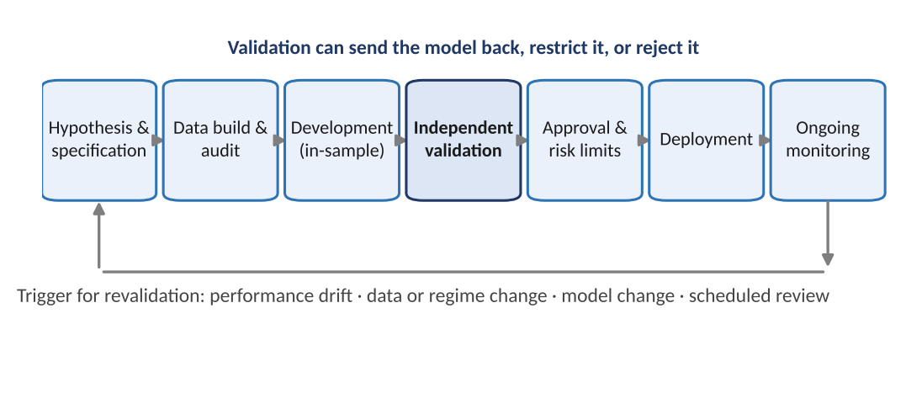
Figure 0.1 — Where validation sits in the life of a model. Independent validation is a gate before approval, and the lifecycle loops: monitoring and changes in data, regime, or the model itself trigger revalidation.

How This Connects to the Rest of the Curriculum
- Research — Validation is the quality-control layer of research: it defines what counts as evidence for a signal, how many candidates were tested, and how large the uncertainty is.
- Optimisation — An optimiser amplifies estimation error, so optimised portfolios need especially careful out-of-sample and cost-aware validation. The regularisation and robustness ideas there reappear in Part 5.
- Macroeconomics — Real-time data, revisions, and regime change (Macroeconomics Part 8) are validation problems; the point-in-time discipline described there is assumed here.
- Risk Metrics — VaR and expected shortfall estimates are models too; Part 6 shows how to test whether they are calibrated.
- Development — Reproducible, versioned, deterministic validation pipelines are infrastructure: seeds, data snapshots, and configuration must be recorded so any result can be re-run.
- Trading — Live monitoring, kill-switches, and capital ramps (Part 9) are validation carried into production.

Glossary of Recurring Terms
Validation — The set of activities that assess whether a model is fit for its intended purpose, including whether its results generalise beyond the data used to build it.
Verification — Checking that a model is implemented as designed: the code does what the specification says.
In-sample / out-of-sample — Data used to fit or select a model versus data kept aside to evaluate it; only the latter estimates future performance.
Overfitting — Fitting noise as if it were signal, so the model performs well on the data it was built on and poorly on new data.
Look-ahead bias — Using information in a test that would not have been available at the decision time.
Survivorship bias — Testing only on assets that still exist today, thereby excluding failures and overstating returns.
Data snooping / p-hacking — Testing many hypotheses on the same data and reporting the best, which inflates apparent significance.
Walk-forward — Repeatedly fitting on a past window and testing on the following one, rolling forward through time.
Purging and embargo — Removing training observations whose labels overlap the test period, and a gap after it, to prevent information leakage.
Sharpe ratio — Mean excess return divided by its volatility, usually annualised; the standard risk-adjusted measure.
Deflated Sharpe ratio (DSR) — The probability that a strategy's true Sharpe ratio is positive after adjusting for the number of trials, skewness, and sample length.
False discovery rate (FDR) — The expected share of rejected hypotheses that are actually null; controlled by the Benjamini–Hochberg procedure.
Backtest (VaR) — Comparing predicted loss thresholds with realised losses and counting exceptions.
Calibration — Agreement between predicted probabilities or quantiles and observed frequencies.
Population stability index (PSI) — A measure of how far a variable's distribution has drifted from a reference distribution.
Model risk — The risk of loss or bad decisions caused by errors in a model or by its misuse.
Challenger model — An alternative model built to benchmark and challenge the production (champion) model.

Part 1 — Foundations: What Validation Is and Why Models Fail
Before any technique, this part sets the vocabulary and the core idea. Validation asks whether a model's apparent performance will survive contact with data it has not seen. The answer depends on how models fail, on the difference between fit and forecast, and on how little signal financial data usually contain.

1.1 Validation, Verification, Backtesting and Monitoring
Level: Beginner
These words are used loosely, but they name different activities with different owners and evidence.
Table 1.1 — The vocabulary of model assurance
Activity | Question it answers | Typical evidence
Verification | Is the model implemented as specified? | Unit tests, reproducing a benchmark by hand, code review, comparing two independent implementations
Conceptual soundness review | Are the theory, assumptions, and data appropriate for the purpose? | Documentation review, assumption tests, literature comparison, sensitivity to assumptions
Calibration / estimation | What parameter values best fit the data? | Fitted parameters, in-sample fit statistics
Validation (outcomes analysis) | Does the model perform well on data it was not built on? | Out-of-sample tests, walk-forward results, backtests, benchmarking against challenger models
Backtesting | Would this rule or estimate have performed well historically (or: did the risk estimate match the realised outcome)? | Historical simulation of a strategy, or exception counts for a VaR model
Ongoing monitoring | Is the model still performing as expected in live use? | Live-versus-backtest tracking, drift statistics, control charts, alert thresholds

A model can pass one of these and fail another. A pricing library can be perfectly verified (it does exactly what it was coded to do) and still be conceptually wrong (the pricing model ignores a feature that matters). A strategy can be implemented correctly and backtest beautifully, and still be a statistical mirage. The word validation in this document covers the whole evidence-gathering chain, with emphasis on outcomes analysis: testing what a model predicts against what actually happens.
Key idea — The intended purpose defines the test.
A model is never valid in the abstract; it is valid for a purpose. A volatility model can be excellent for scaling position sizes and poor for pricing out-of-the-money options. A VaR model can be calibrated at 99% and wrong in the tail beyond. Every validation starts by writing down the intended use, the decisions the model feeds, and the loss if it is wrong. The tests, thresholds, and monitoring all follow from that statement.

1.2 How Financial Models Fail
Level: Beginner
Most failures fall into a small number of families. Knowing the families tells you which test to reach for.
Table 1.2 — A taxonomy of model failure
Failure | What goes wrong | Where it is tested
Overfitting | Parameters or features tuned until they explain noise in the sample | Parts 2, 4 and 5: held-out data, walk-forward, deflation
Look-ahead and leakage | Information from the future (or the test period) enters the model | Parts 2, 3 and 5: purging, timestamps, pipeline audits
Survivorship and selection bias | The sample excludes failures, or was chosen with hindsight | Part 3
Multiple testing | Many variants tried; the best is reported as though it were the only one | Part 4
Unrealistic implementation | Costs, slippage, borrow, capacity, and liquidity ignored | Part 3
Non-stationarity / regime change | Relationships estimated in one era break in the next | Parts 8 and 9: drift detection, stress tests, monitoring
Specification and numerical error | Wrong model form, discretisation error, unstable numerics | Part 7
Misuse | Model applied outside its intended domain or with stale inputs | Part 9: governance and limits

1.3 Generalisation: Fit Is Not Forecast
Level: Beginner → Intermediate
A model's in-sample error measures how well it describes the data used to build it. Its out-of-sample error (the generalisation error) measures how well it predicts new data, and that is the number that matters. A model with enough flexibility can drive in-sample error to zero by memorising the data, while its out-of-sample error rises. This is the bias–variance trade-off: simple models are biased but stable, flexible models are unbiased on the training set but their fitted parameters vary wildly with the particular sample.
Expected test error = Bias² + Variance + Irreducible noise
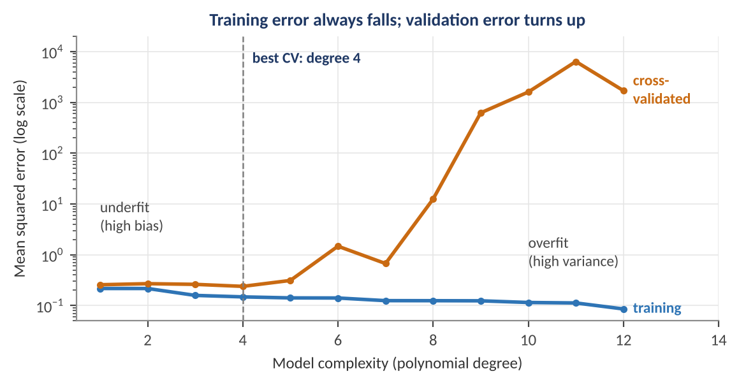
Figure 1.1 — Fitting polynomials of increasing degree to 30 noisy observations of a smooth curve. Training error (blue) falls with every added degree; five-fold cross-validated error (orange) is lowest at degree 4 and explodes beyond degree 8. The in-sample fit alone would have chosen the most complex model, which is the worst.
Worked example — Choosing complexity with held-out data.
In Figure 1.1 the training mean-squared error falls from 0.22 at degree 1 to 0.08 at degree 12: judged only by fit, degree 12 'wins'. The cross-validated error is 0.24 at degree 4 and 1,700 at degree 12 — over 7,000 times worse. The rule that follows is the foundation of the whole document: choose models, features, and parameters by out-of-sample performance, never by in-sample fit, and remember that once a data set has been used to choose, it is no longer out-of-sample.

The same logic applies to every quant technique, from the number of factors in a regression to the lookback window of a momentum rule. Each free choice is a degree of freedom that the data can bend to fit noise. In finance the problem is more severe than in most fields because the noise is large, the sample is small, and the researcher usually has many degrees of freedom.

1.4 The Signal-to-Noise Problem: A Lesson from Random Strategies
Level: Beginner → Intermediate
The best way to understand how easily a backtest deceives is to generate strategies that by construction have no skill and see what the best of them looks like. Consider 200 strategies whose daily returns are pure random noise with a 1% daily standard deviation. Over five years each has a true Sharpe ratio of zero, but each has a measured Sharpe ratio that scatters around zero with a standard error of about 1 / √5 = 0.45.
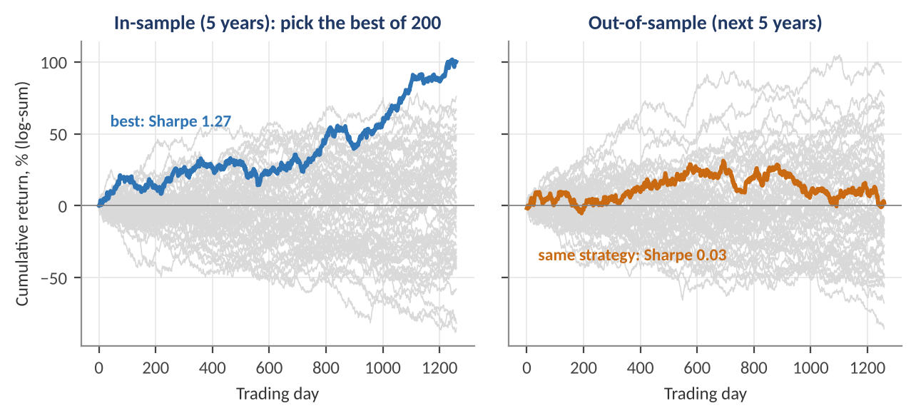
Figure 1.2 — Left: 200 zero-skill strategies over five years (60 shown, grey); the best, selected in-sample, has a Sharpe ratio of 1.27. Right: the same strategies in the following five years. The selected 'winner' has a Sharpe ratio of 0.03; it was luck all along.
Worked example — How many zero-skill strategies look good?
A measured Sharpe ratio above 1.0 is 1.0 / 0.447 = 2.24 standard errors above zero, which a zero-skill strategy achieves with probability 1 − Φ(2.24) = 1.3%. Among 200 random strategies, about 200 × 0.013 = 2.5 are expected to show a Sharpe ratio above 1; the simulation produced two. The best of them reached 1.27 in-sample and 0.03 out of sample. A researcher shown only the winner's backtest would see a persuasive equity curve and a t-statistic near 2.8 — and would have no way to tell it from skill without knowing that 199 other strategies were tried.

The lesson is that a backtest result is only interpretable together with the number of things tried to produce it. A Sharpe ratio of 1.27 selected from one pre-specified idea is moderately impressive; the same number selected from 200 is what noise produces. Parts 2 to 5 give the machinery to account for this: honest splits, significance tests that know about the number of trials, and deflation.
Common mistake — Reporting only the survivor of a search.
Researchers often explore dozens of lookbacks, universes, filters, and parameter settings, then present only the configuration that worked, describing it as 'the strategy'. The rejected variants are part of the evidence, and discarding them removes exactly the information needed to assess the result. Keep a research log that records every variant tried, including the failures.

Part 2 — Data Splitting and Resampling for Time Series
Honest evaluation needs data the model has not influenced. This part covers the standard ways to create it: hold-out splits, walk-forward testing, purged cross-validation for overlapping labels, combinatorial cross-validation for many backtest paths, and the bootstrap for measuring uncertainty. Each technique exists because the simpler one before it leaks information in time-series settings.

2.1 Training, Validation and Test Sets
Level: Beginner
The simplest protocol divides history into three consecutive blocks. The training set is used to fit parameters. The validation set is used to compare models and choose settings such as the lookback window or regularisation strength. The test set is touched once, at the end, to report performance of the single model that was chosen.
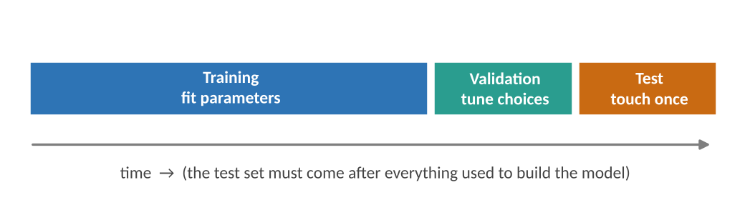
Figure 2.1 — A time-ordered three-way split. The order matters: the test set lies after all data used to build and tune the model, as it would in live trading.
Three rules keep this honest. (1) Respect time order. Randomly shuffling observations before splitting lets the model train on tomorrow to predict yesterday. (2) Use the test set once. Every time you look at the test result and adjust the model, the test set becomes part of the validation set and loses its independence. (3) Make the test set long enough to matter. A test period of one year gives a Sharpe ratio with a standard error near 1.0 (Section 3.4), which cannot distinguish skill from luck.
Worked example — Sizing the splits.
With 15 years of monthly data (180 observations), a 60/20/20 split gives 108 training months, 36 validation months, and 36 test months. A strategy with a true Sharpe ratio of 1.0 would show a measured Sharpe over three years with a standard error of √((1 + 0.5) / 3) = 0.71, so a 95% interval of roughly [−0.4, 2.4]: the test set cannot separate a good strategy from a worthless one. The hold-out protocol is necessary but, with small samples, not sufficient; the techniques below use the data more efficiently.

2.2 Walk-Forward Testing
Level: Intermediate
Walk-forward (or rolling-origin) evaluation repeats the train-then-test step many times, moving forward through history. At each step the model is refitted on data available up to that date and tested on the next block. Concatenating the test blocks gives a long out-of-sample track record that also reveals how the model behaves as it is re-estimated, exactly as it would be in production.
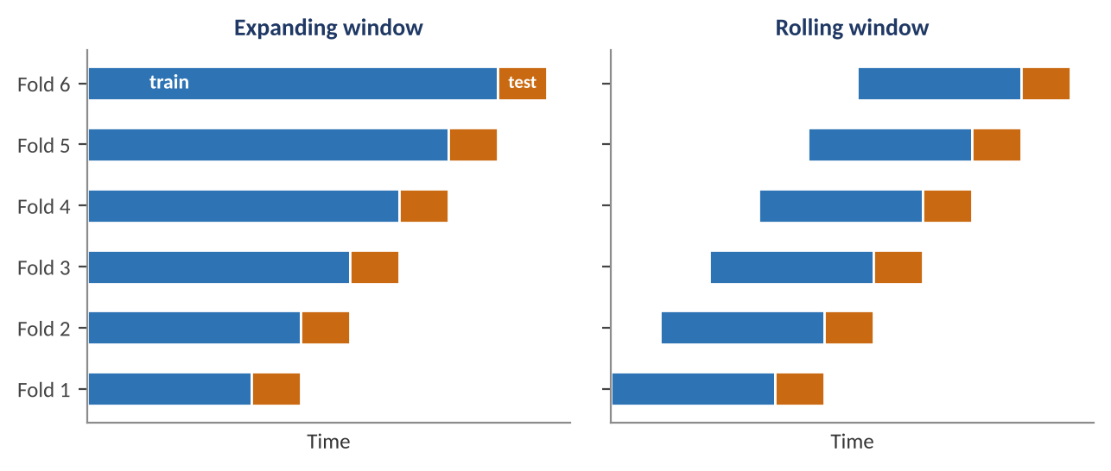
Figure 2.2 — Walk-forward schemes. Left: an expanding window uses all history to date. Right: a rolling window uses only the most recent data, which adapts faster to regime change but estimates parameters from less data.
Table 2.1 — Expanding versus rolling windows
 | Expanding window | Rolling window
Estimation noise | Lower: more data | Higher: fixed shorter window
Adaptation to change | Slow: old data keep weight | Faster: old data are dropped
Best when | Relationships are stable | Relationships drift or regimes shift
Main risk | Stale parameters after a break | Noisy parameters; window length becomes another tunable choice

Worked example — A walk-forward schedule.
With ten years of monthly data, start with a five-year training window and test one year at a time: train on years 1–5, test year 6; train on years 1–6, test year 7; and so on. This produces five test blocks and five years of genuinely out-of-sample performance that can be stitched into one equity curve. Every number in that curve was produced by a model that had seen only earlier data. If the window length or any other setting was chosen by looking at those five years, the walk-forward result is contaminated: nested validation (Section 5.2) is needed.

2.3 Why Ordinary Cross-Validation Leaks, and How Purging Fixes It
Level: Advanced
k-fold cross-validation splits the data into k parts, trains on k − 1 and tests on the held-out part, rotating through all k. It uses data efficiently, and for independent observations it is the right tool. Financial data violate the assumption in two ways. First, observations are serially dependent: adjacent days share volatility regimes and trends. Second, in supervised learning the label is often a forward return over a horizon h (for example, the return over the next 10 days), so the label of an observation at time t uses prices up to t + h. A training observation just before a test fold has a label that overlaps the test period: the model is trained, in effect, on part of the answer.
Two corrections are standard. Purging removes from the training set every observation whose label window overlaps the test fold. Embargo removes an additional short period after the test fold, because serial correlation lets information leak forward from the test period into immediately following training observations.
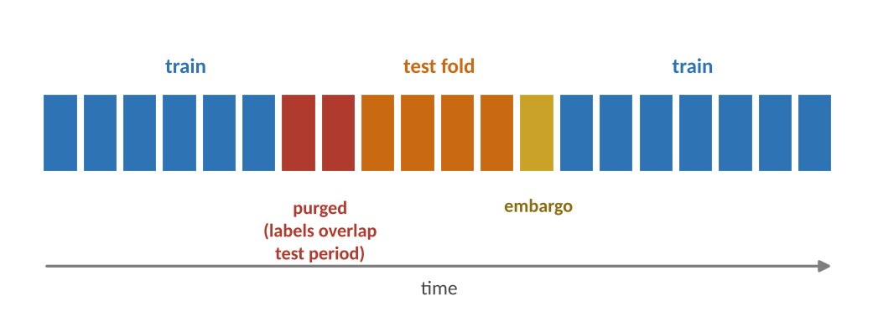
Figure 2.3 — Purged k-fold cross-validation. The orange test fold is held out; red observations immediately before it are purged because their forward-looking labels overlap the test period, and a small embargo (yellow) follows. The remaining blue observations are used for training.
Worked example — Purge and embargo sizes.
A dataset has 1,000 daily observations and a label equal to the 10-day forward return. With five folds of 200 observations each, the label of an observation within 10 days before a test fold overlaps it, so purge 10 observations before the fold. Add an embargo of 1% of the sample, about 10 observations, after the fold. Each interior fold therefore removes 20 training observations — 2% of the data — in exchange for removing the leakage. Skipping the purge in this setting typically inflates cross-validated performance, and the inflation grows with the label horizon and with the autocorrelation of the features.

Tip — Match the purge to the label, not the feature.
The purge length should cover the longest information horizon in the label, including any smoothing applied to features. If a feature uses a 60-day moving average and the label a 10-day forward return, the safest purge is the longer of the two overlaps. When in doubt, purge more: the cost is a few percent of data, the benefit is an honest estimate.

2.4 Combinatorial Purged Cross-Validation (Awareness)
Level: Advanced
Walk-forward produces a single out-of-sample path, which is one draw from a distribution: with luck it looks good, with bad luck bad. Combinatorial purged cross-validation (CPCV) produces many. Divide the sample into N groups. For every choice of k groups as the test set (there are C(N, k) such choices), train on the remaining groups with purging and embargo. Each group appears in the test set in the same number of splits, and the test predictions can be reassembled into several complete, distinct backtest paths.
Number of splits = C(N, k) Number of backtest paths = C(N, k) × k / N
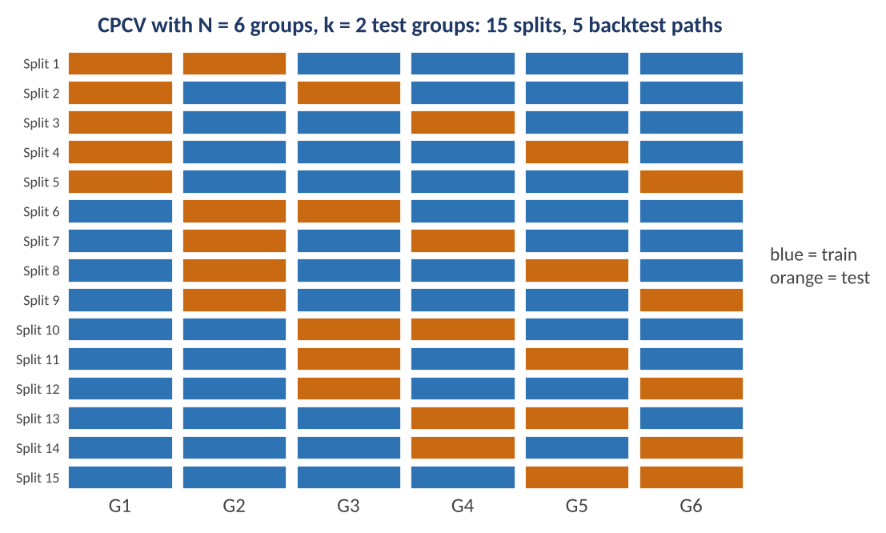
Figure 2.4 — CPCV with N = 6 groups and k = 2 test groups per split. Orange cells are test groups, blue are training. The 15 splits can be recombined into 5 distinct out-of-sample paths, each covering the full history once.
Worked example — Counting splits and paths.
With N = 6 and k = 2 there are C(6, 2) = 15 splits, and each group is in the test set in 15 × 2 / 6 = 5 of them, so the predictions form 5 paths. With N = 10 and k = 2 there are 45 splits and 9 paths. Instead of one Sharpe ratio, the researcher obtains a distribution of path Sharpe ratios; a strategy whose paths range from −0.2 to 1.6 is telling a different story from one whose paths range from 0.7 to 0.9. CPCV costs more computation and requires care with purging, so it is best reserved for final candidates.

2.5 The Bootstrap: Putting Error Bars on Performance
Level: Intermediate → Advanced
A performance statistic computed from one history is a point estimate, and its sampling error is large. The bootstrap estimates that error by resampling the observed returns many times and recomputing the statistic on each resample; the spread of the results approximates the statistic's sampling distribution. Because returns are autocorrelated and volatility clusters, resampling individual days destroys the dependence. The stationary block bootstrap resamples blocks of consecutive observations with random (geometric) lengths, preserving short-range dependence.
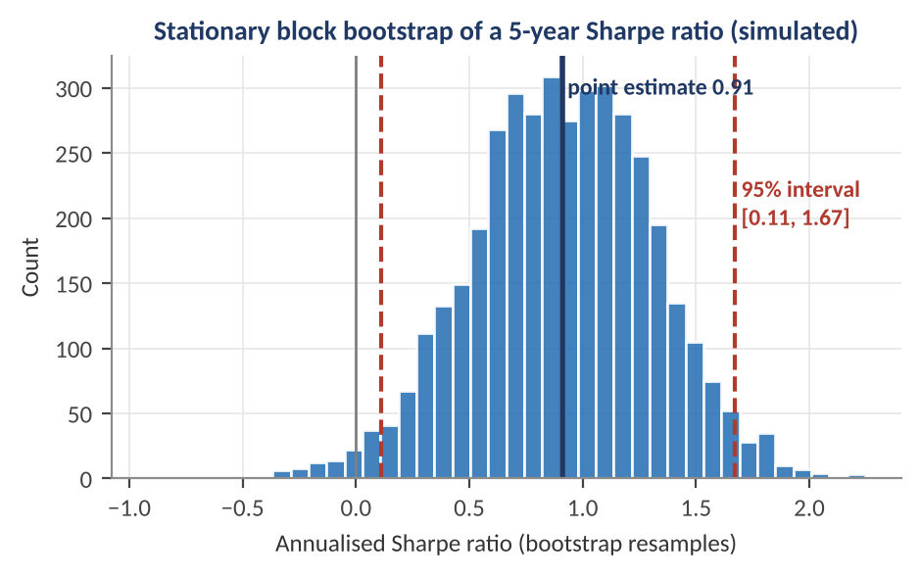
Figure 2.5 — Stationary block bootstrap of the Sharpe ratio of a simulated five-year strategy (mean block length 10 days, 4,000 resamples). The point estimate is 0.91; the 95% interval is [0.11, 1.67] — wide enough that a Sharpe ratio of zero is only just excluded.
Worked example — Reading a bootstrap interval.
The point estimate is 0.91 and the bootstrap percentiles give a 95% interval of [0.11, 1.67]. The interval says two things at once: the strategy is probably better than nothing, and the true Sharpe ratio could plausibly be anywhere from almost zero to very high. A decision rule should use the interval, not the point: if the capital allocation only makes sense above a Sharpe ratio of 0.5, this evidence does not support it. Note that the bootstrap quantifies sampling noise for this history; it does not account for selection (Part 4) or regime change.

Common mistake — Using the bootstrap to 'prove' significance after a search.
Bootstrapping the winner of a 200-strategy search produces a tight-looking interval around an inflated number. The bootstrap measures the noise in the selected series, not the selection effect. Combine it with the multiple-testing tools of Part 4, or bootstrap the entire selection procedure (for example, as in White's reality check).

Part 3 — Backtesting Trading Strategies
A backtest simulates a strategy on historical data. It is the most used and most abused validation tool in finance. Done carefully it is a useful check on logic and a rough guide to risk; done carelessly it is a machine for manufacturing false confidence. This part covers what a backtest consists of, the biases that corrupt it, the cost of trading, and how to measure results with their uncertainty.

3.1 Anatomy of a Backtest
Level: Beginner
Every backtest transforms data into a profit-and-loss series through the same chain of stages, and each stage is a place where errors enter. A vectorised backtest applies the strategy to whole arrays at once; it is fast and good for research but easy to contaminate with future data. An event-driven backtest steps through time and feeds the strategy only what was known at each moment, which is slower but structurally prevents look-ahead and models execution more realistically.
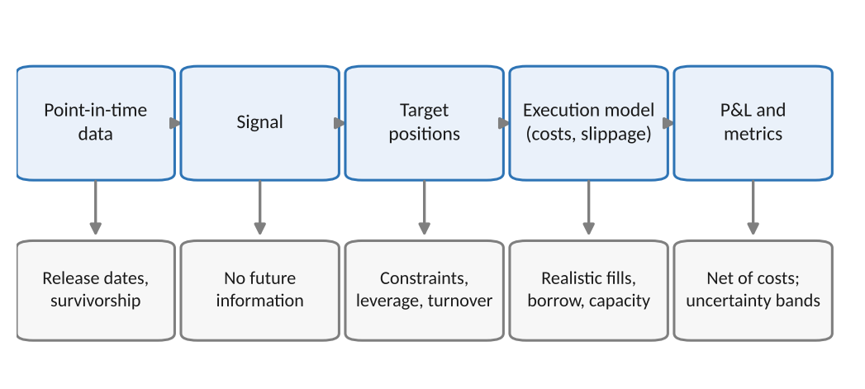
Figure 3.1 — The stages of a backtest and the check that belongs to each. Errors compound: a flaw in the data stage (for example, using revised figures) flows through every later stage and is invisible in the final equity curve.
The core identity of the P&L is simple, and it highlights the two places where backtests are most often optimistic: the position used (was it knowable?) and the cost subtracted (was it realistic?):
Net return_{t} = Position_{t−1} × Asset return_{t} − Cost(ΔPosition_{t})
Note the lag: the position held over period t must be decided with information up to t − 1. A single-index error here — using the same day's close to decide a trade that earns the same day's return — is the commonest source of an impossibly good backtest.

3.2 The Biases That Corrupt a Backtest
Level: Beginner → Intermediate
Table 3.1 — Common backtest biases
Bias | How it arises | Effect | Defence
Look-ahead bias | Using data not yet published or knowable at the decision time (restated financials, revised macro data, future index membership) | Inflates returns, often dramatically | Point-in-time data; lag every input by its real release delay; event-driven simulation
Survivorship bias | Testing only on assets that exist today; delisted, bankrupt, and merged names are missing | Overstates returns; understates drawdowns | Use universes that include dead securities with delisting returns
Selection / data-snooping bias | Choosing the universe, period, or rule after seeing results | Overstates significance | Pre-register the specification; count variants; hold out data
Time-period bias | A sample dominated by one regime (for example, falling rates) | Edge that disappears when the regime changes | Evaluate by sub-period and regime; test on other markets
Unrealistic fills | Trading at the close price used to generate the signal, or in sizes the market cannot absorb | Overstates returns, especially for small caps and fast signals | Execution lag; market-impact and capacity model
Short-sale and financing assumptions | Assuming unlimited borrow at zero cost | Overstates short-side profits | Use borrow availability and fees; include financing cost

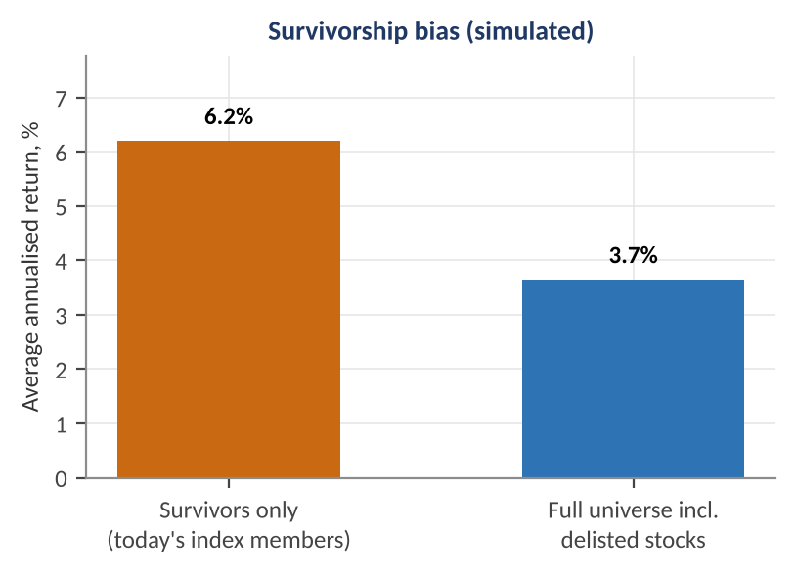
Figure 3.2 — Survivorship bias in a simulated universe of 600 stocks over ten years. About 10% of stocks collapse and are delisted. Measuring only the survivors gives an average return of 6.2% a year; including the delisted stocks gives 3.7%. A strategy tested on today's survivors earns the first number in the backtest and the second in reality.
Worked example — The cost of survivorship.
In the simulation, survivors earned 6.2% a year on average while the full universe, including stocks that were delisted after large losses, earned 3.7% — a gap of 2.5 percentage points a year. A long-only strategy that simply holds 'the index constituents' would overstate its edge by that amount purely from the selection of the universe. For a strategy whose true alpha is 2%, survivorship alone makes a no-skill version look as good as the real thing. The gap is typically larger for small caps, value strategies (which buy distressed names), and long histories.

Common mistake — Using today's index membership for a historical backtest.
A list of current S&P 500 members contains, by construction, the companies that grew enough to be members now. Backtesting a rule on that list from 1995 includes the future winners and excludes the stocks that were in the index and fell out. Historical constituent lists, with additions, deletions, and delisting returns, are a necessary input, not a luxury.

3.3 Transaction Costs, Slippage and Capacity
Level: Intermediate
Every trade costs money: the bid–ask spread (half of it per side), commissions and fees, market impact (moving the price against yourself, which grows with trade size relative to volume), and, for short positions, borrow fees. Costs scale with turnover — how much the portfolio trades — so a signal with a modest edge and high turnover can have a high gross Sharpe ratio and a negative net one.
Net Sharpe ≈ [ μ_{gross} − Turnover × c ] / σ
Here μ_{gross} is the annual gross return, σ the annual volatility, Turnover the annual one-way trading as a multiple of capital, and c the all-in cost per unit traded (as a fraction).
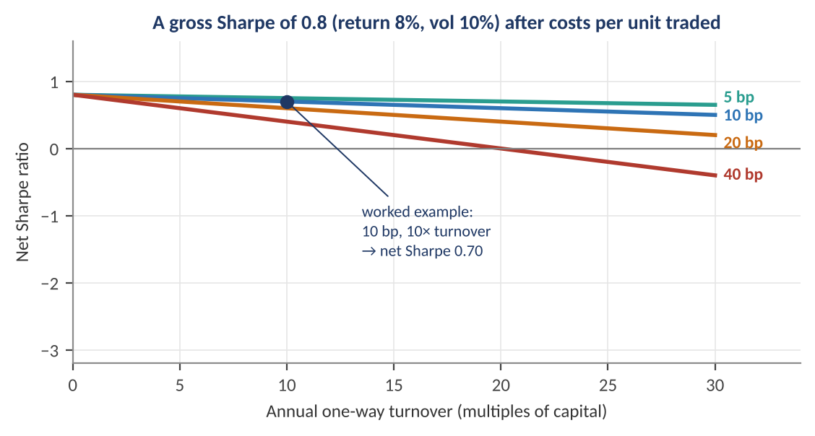
Figure 3.3 — Net Sharpe ratio as turnover rises, for a strategy with 8% gross return and 10% volatility under four cost levels (basis points per unit traded). At 40 bp, the strategy loses money net at any turnover above 20× a year; at 5 bp it barely notices.
Worked example — Gross versus net.
A strategy earns 8% a year gross with 10% volatility: gross Sharpe 0.80. It turns over its capital 10 times a year and costs 10 bp per unit traded. The annual cost drag is 10 × 0.0010 = 1.0%, so net return is 7.0% and the net Sharpe is 0.70. Doubling turnover to 20× makes the drag 2.0% and the net Sharpe 0.60; at 40 bp and 20× turnover the drag is 8.0% and the net Sharpe is 0.00. The honest comparison between two signals is always net, and cost estimates should be conservative and tested for sensitivity, because the cost assumption is the most uncertain input to a backtest of a fast strategy.

Capacity is the amount of capital a strategy can run before its own trading erodes the edge. Market impact is usually modelled as growing with the square root of trade size relative to daily volume, so doubling assets under management less than doubles costs but more than halves net alpha per unit of capital for liquid-constrained strategies. A validated strategy states the capacity at which its net Sharpe ratio falls below the required hurdle.

3.4 Performance Metrics and Their Uncertainty
Level: Intermediate
Several statistics summarise a backtest, and each answers a different question. All are random variables computed from one history, so each has sampling error.
Table 3.2 — Standard performance measures
Measure | Definition | What it tells you
Annualised return | Compound growth rate of the equity curve | Absolute performance
Annualised volatility | Standard deviation of returns × √(periods per year) | Return variability
Sharpe ratio | Mean excess return / volatility, annualised: SR = (μ − r_{f}) / σ | Return per unit of total risk
Sortino ratio | Mean excess return / downside deviation | Return per unit of downside risk
Maximum drawdown | Largest peak-to-trough fall: min over t of (V_{t} / max_{s≤t} V_{s} − 1) | Worst loss an investor would have experienced
Calmar ratio | Annualised return / |maximum drawdown| | Return per unit of worst-case pain
Hit rate and profit factor | Share of winning periods; gross profit / gross loss | Shape of the payoff; need to be read with average win and loss
Turnover and holding period | Annual one-way trading; average time in a position | Cost exposure and signal speed

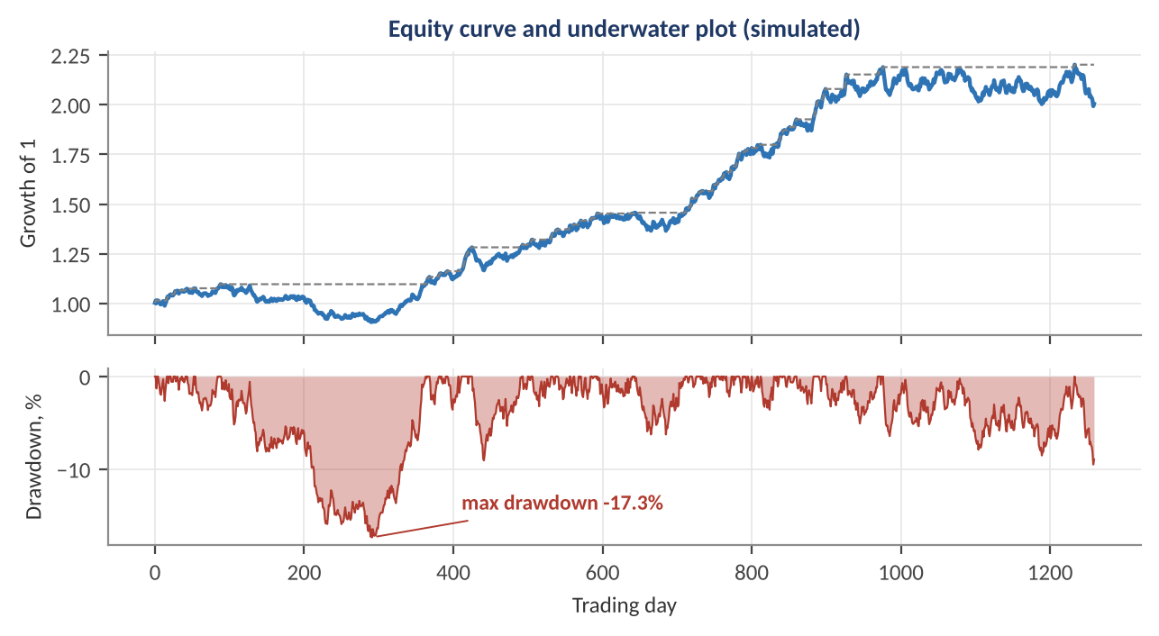
Figure 3.4 — A simulated five-year equity curve (top) and its underwater plot (bottom). The maximum drawdown is 17.3% and is followed by a long recovery. Drawdown depth, duration, and time to recover are what investors actually live through.
Worked example — Drawdown and Calmar.
An equity curve runs 100 → 110 → 121 → 108.9 → 98 → 105 → 115.5. The running peak reaches 121; the lowest point after it is 98, so the maximum drawdown is 98 / 121 − 1 = −19.0%. At the last point the curve is still 4.5% below its peak. If the strategy's annualised return is 12% over this history, the Calmar ratio is 0.12 / 0.19 = 0.63. Because the maximum drawdown is a single extreme observation, it is a poor estimate of future worst-case loss: it tends to be exceeded by a longer history (Section 9.3 shows how far).

How uncertain is a Sharpe ratio?
For independent returns, the standard error of an annualised Sharpe ratio estimated from T years of data is approximately:
SE(SR) ≈ √[ (1 + ½ · SR²) / T ]
It shrinks only with the square root of history, which means that confirming a modest Sharpe ratio takes years. Skewness, excess kurtosis, and autocorrelation widen the interval further (the exact expression is given in the Deflated Sharpe section).
Worked example — Confidence interval for a Sharpe ratio.
A strategy shows SR = 1.0 over 5 years: SE = √[(1 + 0.5) / 5] = 0.55, so a 95% interval is 1.0 ± 1.96 × 0.55 = [−0.07, 2.07], which includes zero (SR / SE = 1.83). With 10 years of the same Sharpe ratio, SE = 0.39, the interval is [0.24, 1.76] and SR / SE = 2.58. A strategy with SR = 0.5 over 10 years has SE = 0.34 and SR / SE of only 1.49. Solving for the history needed to make the interval exclude zero (SR / SE ≥ 2) gives a rule of thumb: a Sharpe ratio of 1.0 needs about six years of independent data, and a Sharpe ratio of 0.5 needs about eighteen.

Understand before proceeding — A backtest is evidence about the past, not a forecast.
Even a clean, bias-free backtest with costs only shows what would have happened had the same rule been followed. It becomes evidence about the future only through the argument that the economic mechanism behind the rule persists. This is why an economic rationale matters (Section 5.5): a rule with a clear reason to work earns more credence than a pattern whose only support is its in-sample performance.

Part 4 — Statistical Significance and Multiple Testing
A positive backtest answers 'what happened?'. Statistical testing asks 'could this have happened by chance?'. For finance the second question is hard for three reasons: returns are not independent, many strategies are tried, and the interesting effects are small. This part builds up from a single test to the corrections that account for how many tests were run, ending with the deflated Sharpe ratio.

4.1 Testing a Strategy's Mean Return
Level: Beginner → Intermediate
The simplest test asks whether the mean return of a strategy is different from zero. With T independent observations of mean r̄ and standard deviation s, the t-statistic is t = r̄ / (s / √T). It is closely related to the Sharpe ratio: for a period-by-period Sharpe ratio, t = SR_{period} × √T, and with annualised SR and a history of T_{y} years:
t = SR_{annual} × √T_{y}
Worked example — From Sharpe ratio to t-statistic.
An annualised Sharpe ratio of 1.0 over 5 years gives t = 1.0 × √5 = 2.24, a two-sided p-value of about 0.025: significant at the 5% level on its own. Over 2 years the same Sharpe ratio gives t = 1.41 (p = 0.16); to reach t = 3.0, the 'discovery' threshold discussed later, a Sharpe ratio of 1.0 needs 9 years. The same arithmetic shows why short backtests of attractive strategies prove little.

The standard formula assumes independent, identically distributed returns. Real strategy returns violate this in ways that usually overstate the t-statistic.
- Autocorrelation — if returns have first-order autocorrelation ρ, the variance of the sample mean is inflated by roughly (1 + ρ) / (1 − ρ), so the t-statistic must be divided by the square root of that factor. For ρ = 0.2 the factor is 1.5, and t falls from 2.24 to 2.24 / √1.5 = 1.83. Use heteroskedasticity-and-autocorrelation-consistent (HAC, Newey–West) standard errors.
- Overlapping observations — regressing 12-month forward returns on a monthly signal produces overlapping observations that share eleven of twelve months. With 300 monthly rows there are only about 300 / 12 = 25 independent observations, so ordinary standard errors can be too small by a factor of three.
- Non-normality — negative skewness and fat tails make Sharpe ratios look better than the risk warrants, and widen their sampling distribution (see the Deflated Sharpe ratio below).
- Time-varying volatility — a strategy that sells insurance earns small gains most periods and rare large losses; a sample without a loss event gives a deceptively high t-statistic.

4.2 The Multiple-Testing Problem
Level: Intermediate
A 5% significance threshold means a true null hypothesis is rejected 5% of the time. Test one hypothesis and a 5% false-positive rate is acceptable. Test 100 and the arithmetic changes. The probability of at least one false positive among m independent tests at level α is:
P(at least one false positive) = 1 − (1 − α)^{m}
Worked example — How fast false positives accumulate.
With m = 100 tests at α = 5%, the expected number of false positives is 5, and the probability of at least one is 1 − 0.95¹⁰⁰ = 99.4%. With 40 tests, the expected count is 2 and the chance of at least one is 87%. A research process that tries 100 signals and publishes the one with p < 0.05 is essentially certain to find one, whether or not any real edge exists — exactly the pattern of Figure 1.2.

Two families of correction deal with this, and they control different things.
Table 4.1 — Multiple-testing corrections
Method | Controls | Rule | Behaviour
Bonferroni | Family-wise error rate (probability of any false positive) | Reject if p ≤ α / m | Simple and very conservative; low power when m is large
Holm (step-down) | Family-wise error rate | Sort p-values; reject p₍ᵢ₎ ≤ α / (m − i + 1) until the first failure | Uniformly at least as powerful as Bonferroni
Benjamini–Hochberg (BH) | False discovery rate (expected share of rejections that are false) | Sort p-values; find the largest i with p₍ᵢ₎ ≤ i α / m and reject the first i | More powerful; appropriate when screening many candidates and some false leads are tolerable

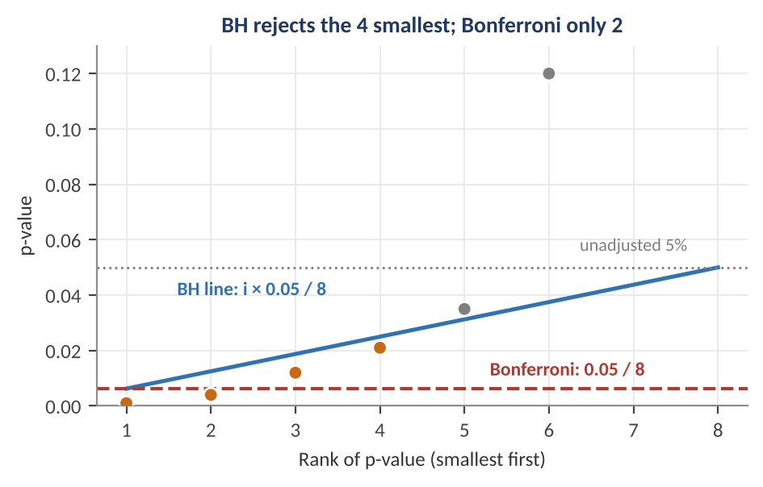
Figure 4.1 — Eight sorted p-values against the Benjamini–Hochberg line (blue) and the Bonferroni threshold (red dashed). BH rejects the four smallest p-values, which lie on or below the blue line up to rank 4; Bonferroni rejects only the two below 0.00625.
Worked example — Eight candidate signals.
Eight signals have sorted p-values 0.001, 0.004, 0.012, 0.021, 0.035, 0.12, 0.30, 0.55, and the target level is α = 0.05. Bonferroni: threshold 0.05 / 8 = 0.00625, so only the first two (0.001, 0.004) are rejected. Holm: 0.001 ≤ 0.05/8 and 0.004 ≤ 0.05/7 pass; 0.012 > 0.05/6 = 0.0083 fails, so two are rejected. BH: the thresholds are 0.0063, 0.0125, 0.0188, 0.025, 0.031, … The fourth p-value 0.021 ≤ 0.025 passes, but 0.035 > 0.031 fails, so the first four are declared discoveries, with an expected false-discovery share of at most 5%. Unadjusted, five of the eight would have been called significant; the corrections cut that to two or four, depending on the error rate you choose to control.

Key idea — Count the tests you did, not the tests you reported.
The m in these formulas is the number of hypotheses tested, including the discarded ones and the informal ones (every chart looked at, every parameter changed after seeing a result). It is usually underestimated. A researcher who cannot say how many variants were tried cannot compute a valid p-value; a conservative estimate is better than the reported count.

4.3 Selection Bias and the Deflated Sharpe Ratio
Level: Advanced
Multiple-testing corrections work on p-values. For strategy selection, a more direct approach asks: given that I tried N strategies and chose the best, how high a Sharpe ratio would the best one reach purely by luck? If N independent zero-skill strategies each have an estimated Sharpe ratio with standard deviation σ_{SR}, the expected maximum is approximately:
E[max SR_{N}] ≈ σ_{SR} · [ (1 − γ) · Φ⁻¹(1 − 1/N) + γ · Φ⁻¹(1 − 1/(N·e)) ] γ ≈ 0.5772
Here Φ⁻¹ is the inverse of the standard normal distribution function and γ is Euler's constant. The expected best-of-N grows slowly but steadily with N, as Figure 4.2 shows.
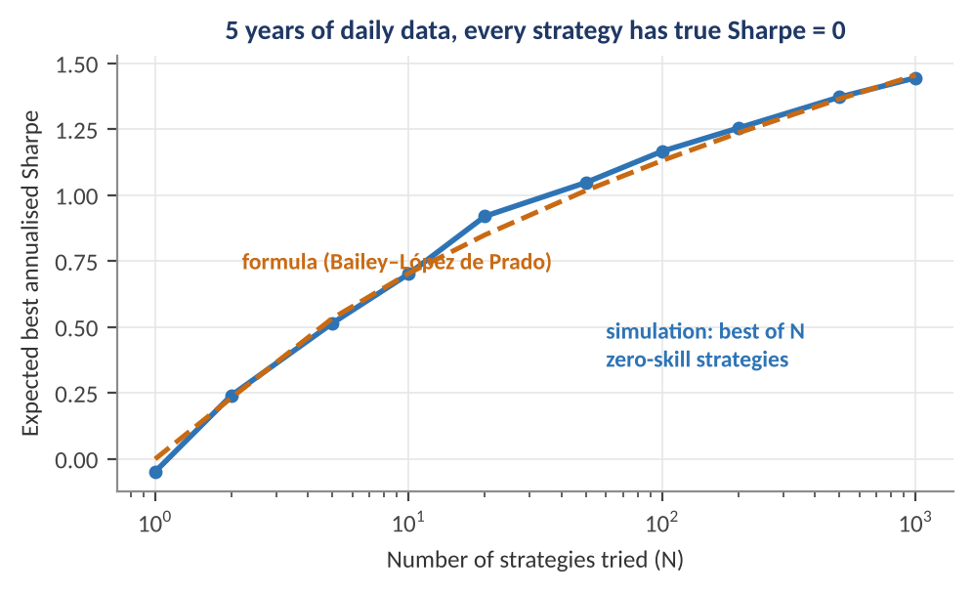
Figure 4.2 — The expected best annualised Sharpe ratio among N zero-skill strategies tested on five years of daily data. The simulation (blue) and the formula (orange) agree closely: with 100 strategies the best looks like 1.2; with 1,000, 1.45 — all of it noise.
Worked example — The luck benchmark.
With σ_{SR} = 1 / √5 = 0.447 (five years), the formula gives an expected best of 0.45 × 1.57 = 0.70 for N = 10, 1.13 for N = 100, and 1.46 for N = 1,000. Therefore a strategy chosen from 100 candidates must show a Sharpe ratio well above 1.1 before it even beats what luck delivers on average. A researcher who tried a hundred parameter combinations and reports 1.0 has, in effect, reported nothing.

The Deflated Sharpe Ratio (DSR) of Bailey and López de Prado turns this into a probability. It tests whether the selected strategy's Sharpe ratio exceeds the luck benchmark SR₀ = E[max SR_{N}], while also correcting for non-normal returns and finite sample length:
DSR = Φ [ (SR̂ − SR₀) · √(T − 1) / √(1 − γ₃ · SR̂ + ((γ₄ − 1) / 4) · SR̂²) ]
Here SR̂ is the observed Sharpe ratio (per period, not annualised), T the number of observations, γ₃ the skewness and γ₄ the kurtosis (3 for a normal distribution) of the returns. A DSR above 0.95 means that, after allowing for the number of trials and the shape of returns, there is at least a 95% probability that the true Sharpe ratio is positive.
Worked example — Deflating a Sharpe ratio.
A strategy shows an annualised Sharpe ratio of 1.5 over 60 months (monthly SR̂ = 1.5 / √12 = 0.433), skewness −0.5 and kurtosis 4.0. It was selected from N = 100 trials whose monthly Sharpe estimates had a standard deviation of 1 / √60 = 0.129. Then SR₀ = 0.129 × 2.53 = 0.327 monthly, which is 1.13 annualised. The denominator is √(1 − (−0.5)(0.433) + (3/4)(0.433)²) = √(1 + 0.217 + 0.141) = 1.165, so DSR = Φ[(0.433 − 0.327) × √59 / 1.165] = Φ(0.70) = 0.76. Ignoring the number of trials (SR₀ = 0) gives Φ(2.9) = 0.998. The same backtest is 'virtually certain to be skilful' when judged alone and only 76% likely to be skilful once the search is accounted for — below the 95% bar.

Minimum backtest length
The same formula can be inverted to ask how much data is needed. If a researcher tries N configurations, the history must be long enough that the best random strategy would not reach the target Sharpe ratio by chance. With a target of an annualised Sharpe ratio of 1, the required length in years is approximately the square of the bracketed term above: (1 − γ)Φ⁻¹(1 − 1/N) + γΦ⁻¹(1 − 1/(Ne)). That gives 2.5 years for N = 10, 6.4 years for N = 100, and 10.6 years for N = 1,000: the more you search, the longer the history you need. Most research processes use far fewer years than the number of variants they try would require.
Tip — Fix the hurdle before you search.
Harvey, Liu and Zhu argue that, given the volume of factor research, a newly discovered factor should clear a t-statistic of about 3.0 (a two-sided p-value of roughly 0.0027), not 2.0. The exact figure depends on how many tests are implicitly in the literature, but the direction is clear: the more people search, the higher the bar. Decide the bar in advance, not after seeing which candidates clear it.

4.4 Reality Checks and Backtest Overfitting (Awareness)
Level: Advanced
Several formal procedures test whether the best of many strategies is genuinely better than a benchmark, by resampling the whole selection process rather than a single series. White's Reality Check and Hansen's Superior Predictive Ability (SPA) test use the bootstrap to build the null distribution of the best performance statistic across all candidates, so the p-value reflects the whole search. Probability of Backtest Overfitting (PBO), computed with combinatorial symmetric cross-validation, estimates how often the strategy that is best in-sample ranks below the median out-of-sample across many train–test partitions of the data. A PBO near 0 means in-sample winners tend to remain winners; a PBO near 50% or higher means in-sample selection carries no information about out-of-sample rank.
- What they require — the full matrix of candidate-strategy returns for the same dates, not just the returns of the winner. This is another reason to log every trial.
- What they cannot fix — they test for selection bias within the candidate set you provide. They cannot detect look-ahead bias in the data, and they cannot account for ideas you tried on paper and never coded.
- How to use them — as a final gate for a short list of candidates, alongside the economic argument for each.

Part 5 — Overfitting Control and Model Selection
Parts 2 to 4 test a finished model. This part is about building one without overfitting: choosing among models, tuning hyperparameters, avoiding leakage in the feature pipeline, checking that results do not hinge on a lucky parameter setting, and keeping the number of free choices small.

5.1 Penalising Complexity: Information Criteria
Level: Intermediate
Cross-validation is the most general way to compare models, but it can be expensive and noisy. Information criteria offer a quick, in-sample alternative that adds a penalty for the number of fitted parameters k. For a regression with Gaussian errors, n observations, and residual sum of squares RSS:
AIC = n · ln(RSS / n) + 2k
BIC = n · ln(RSS / n) + k · ln(n)
Lower is better. The first term rewards fit; the second penalises complexity. The AIC targets predictive accuracy and tolerates more parameters; the BIC penalises each parameter by ln(n), which exceeds 2 once n > 7, so it favours smaller models and is more consistent when a true simple model exists.
Table 5.1 — Model comparison with 200 observations
Model | Parameters k | RSS | AIC | BIC
Simple factor model | 2 | 260 | 56.5 | 63.1
Moderate factor model | 4 | 212 | 19.7 | 32.8
Rich factor model | 8 | 205 | 20.9 | 47.3

Worked example — Does the extra complexity pay?
Going from 4 to 8 parameters reduces RSS only from 212 to 205: a 3% improvement for a doubling of parameters. With n = 200, AIC rises from 19.7 to 20.9 and BIC from 32.8 to 47.3, so both criteria prefer the four-parameter model. The richer model fits 7 units of squared error better in-sample, which is about what four irrelevant parameters would be expected to absorb by chance. Information criteria do not replace out-of-sample tests, and they do not account for the search that produced the candidate models, but they are a useful discipline against adding terms that the data cannot support.

Regularisation
An alternative to choosing the number of parameters is to keep many but shrink them. Ridge (L2) regression adds a penalty λΣβⱼ² that shrinks coefficients smoothly; lasso (L1) adds λΣ|βⱼ|, which also sets some coefficients exactly to zero (feature selection); elastic net combines both. The strength λ is itself a hyperparameter chosen by validation. In finance, shrinking toward zero, toward equal weights, or toward a benchmark is often worth more than any model refinement, because it counteracts the estimation error that dominates small samples (see the shrinkage discussion in the Optimisation module).

5.2 Hyperparameter Tuning and Nested Validation
Level: Advanced
A hyperparameter is a setting not learned from the data directly: a lookback window, a regularisation strength, a tree depth, a threshold. They are chosen by trying values and comparing validation performance. The danger is subtle: if you use the same validation scores to choose the best hyperparameters and to report the performance, the reported number is biased upward by the selection.
Nested validation separates the two jobs. An inner loop chooses hyperparameters using only the training data of each outer fold; an outer loop evaluates the chosen configuration on data the inner loop never saw. For time series, both loops must respect order (an inner walk-forward inside each outer walk-forward step) and use purging where labels overlap.
Worked example — The size of the selection bias.
Suppose 20 hyperparameter settings are compared on one validation window, and every setting has a true Sharpe ratio of 0.5 with a standard error of 0.45 on that window. The best of 20 will, on average, score about 0.5 + 0.45 × 1.87 ≈ 1.34 (1.87 is the expected maximum of 20 standard normal draws). Reporting 1.34 as the performance of the tuned model overstates the truth by 0.84. In a nested design, the outer fold would evaluate the selected setting on fresh data and report roughly 0.5, which is the honest number.

Common mistake — Tuning on the test set 'just a little'.
Looking at test results and then adjusting the model, even slightly and even with good intentions, converts the test set into a second validation set. After several such rounds the test result is as biased as a validation result. If the test set has been influenced, say so and treat the result as in-sample; the only cure is new data (a later period, another market, or live trading).

5.3 Leakage in the Feature Pipeline
Level: Intermediate → Advanced
Leakage happens whenever information from the test period contaminates model building, and it often hides in routine data preparation rather than in the model itself.
Table 5.2 — Common sources of leakage
Source | Example | Fix
Whole-sample normalisation | Standardising a feature with the mean and standard deviation of the full history | Compute scaling statistics on the training window only (expanding or rolling), then apply to later data
Whole-sample filtering and smoothing | Using a two-sided filter, a smoothed regime probability, or an HP-filter trend that uses future data | Use one-sided (causal) filters; use filtered, not smoothed, probabilities
Target leakage | A feature derived from, or highly correlated with, the outcome measured after the fact (for example, a restated earnings figure) | Check feature timestamps; use vintage data
Cross-sectional leakage | Ranking or neutralising across stocks using data from the same period as the label | Align the information set to the decision time
Feature selection before splitting | Choosing the 10 best features on the full data, then cross-validating | Put feature selection inside each training fold
Duplicate and related samples | The same event or overlapping window appears in both train and test | Group-aware splitting; purge and embargo

Worked example — Leakage from feature selection.
A researcher has 500 candidate features, all pure noise, and 250 observations. Selecting the 10 features most correlated with the target on the full sample and then running cross-validation gives an apparent out-of-sample R² well above zero, because the selected features were chosen using the held-out observations as well. The same procedure with selection performed inside each training fold produces an R² near or below zero, which is the truth. A simple audit is to run your entire pipeline on randomly shuffled labels: if it still reports skill, the pipeline leaks.

5.4 Parameter Stability and Sensitivity Analysis
Level: Intermediate
A robust strategy should not depend on a precise parameter value. If performance collapses when a lookback window moves from 20 to 22, the edge was found by tuning noise. A sensitivity analysis evaluates the performance over a grid of nearby parameter values and looks at the shape of the surface.
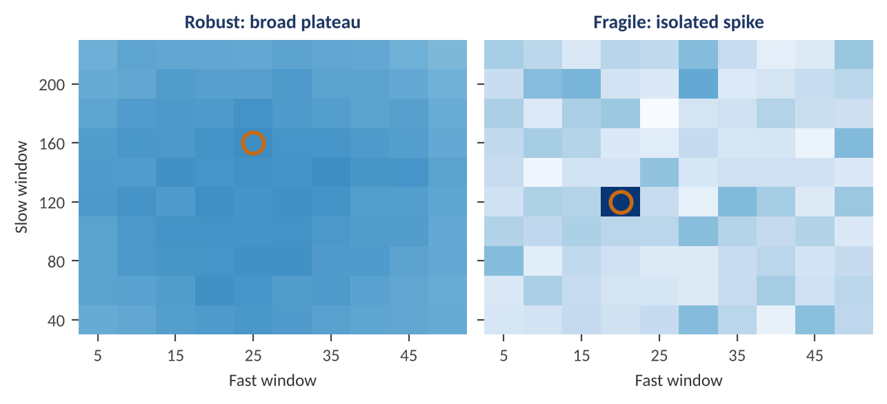
Figure 5.1 — Sharpe ratio across a grid of fast and slow moving-average windows (darker is higher). Left: a broad plateau; neighbouring settings perform similarly, and the chosen point (circled) is representative. Right: an isolated spike; the circled setting reaches 1.55 while the grid average is 0.18 — the signature of a fitted accident.
Worked example — Plateau versus spike.
In the robust grid, the best cell has a Sharpe ratio of 0.92 and its neighbours score within about 0.1 of it, so choosing a nearby setting loses little: the strategy's quality is a property of the idea. In the fragile grid the best cell scores 1.55 but the average cell scores 0.18 and its immediate neighbours are around zero: the best result is a single lucky draw out of about 100. The practical rule is to choose parameters in the middle of the best region rather than at its single highest point, and to report the performance of the region (for example, the median across the neighbourhood), not of the peak.

- Perturb the inputs — add noise to prices, shift signal timing by a day, drop 10% of observations at random, change the universe slightly. A genuine edge degrades gracefully.
- Change the market, not just the parameters — an idea that works in several related markets or sub-periods is far more credible than one tuned to a single series.
- Check the cost sensitivity — a strategy that survives only at the most optimistic cost assumption is fragile in practice.

5.5 Parsimony, Economic Rationale and the Degrees-of-Freedom Budget
Level: Beginner → Intermediate
Statistical tools reduce the risk of fooling yourself, and design discipline reduces it further. Three practices matter most.
- Write the economic hypothesis first. State why the effect should exist, who is on the other side of the trade, and why they would keep paying. A signal with a mechanism (compensation for bearing a risk, a behavioural bias, a structural constraint) deserves a lower evidence hurdle than one with none.
- Keep a degrees-of-freedom budget. Count the free choices: parameters, features, universe filters, rebalancing rules, and sample dates. Every one consumes evidence. A model with three parameters fitted on 25 independent observations is already stretched.
- Prefer simple models and shrinkage. Equal weights, sign-based signals, and a small set of well-motivated features are hard to overfit and easy to audit. Add complexity only when it earns out-of-sample, net of the cost of the extra degrees of freedom.
Understand before proceeding — A complex model needs more evidence, not less.
A neural network with a million parameters trained on 20 years of monthly data can fit anything. The correct response is not to avoid such models but to require proportionally stronger validation: more independent test data, heavy regularisation, ensembling across seeds, and a comparison against a simple baseline that the complex model must beat by a margin that survives costs.

Part 6 — Validating Risk Models: VaR, Expected Shortfall and Calibration
A risk model makes a testable promise. A 99% one-day Value-at-Risk (VaR) of 2% says: on only one day in a hundred should the loss exceed 2%. Unlike an alpha model, whose edge is small and slow to confirm, a risk model produces many observable outcomes — every day is a trial — so it can be tested directly. This part covers how to count and interpret VaR exceptions, the Kupiec and Christoffersen tests, the Basel traffic-light framework, the extension to expected shortfall, and probability-integral-transform checks for full distribution forecasts.

6.1 What a VaR Backtest Tests
Level: Beginner
Let r_{t} be the portfolio return on day t and VaR_{t}(p) the model's forecast, made the previous evening, of the loss that will be exceeded with probability p (for example p = 1%). Define the exception (hit) indicator:
I_{t} = 1 if r_{t} < −VaR_{t}(p), otherwise I_{t} = 0
If the model is right, the hit sequence has two properties, and a backtest checks each:
- Unconditional coverage — the long-run proportion of exceptions equals p. Too many exceptions means the model understates risk; too few means it is overly conservative and ties up capital.
- Independence — exceptions should not cluster. A model that is right on average but fails in bunches (for example, in every volatility spike) is not tracking changing risk, and clustered losses are exactly when the damage is largest.
Together they say I_{t} is an independent Bernoulli(p) sequence, which is the conditional coverage hypothesis. The number of exceptions in n days then follows a binomial distribution, which gives us exact probabilities for any count.
Worked example — Counting exceptions.
A bank reports a 99% one-day VaR over the last 250 trading days. If the model is correct the expected number of exceptions is 250 × 0.01 = 2.5. The probability of seeing four or fewer is 89.2%; five or more happens 10.8% of the time even for a perfect model; ten or more happens only 0.025% of the time. So five exceptions is unremarkable noise, but ten is strong evidence that the model is wrong. The challenge is the band between: deciding when a count is evidence and when it is luck.

6.2 The Basel Traffic Light and the Kupiec Test
Level: Intermediate
Regulators turned the binomial logic into a simple rule for market-risk capital under the Basel framework. For a 99% VaR backtested over 250 days, the number of exceptions places the model in one of three zones (Figure 6.1):
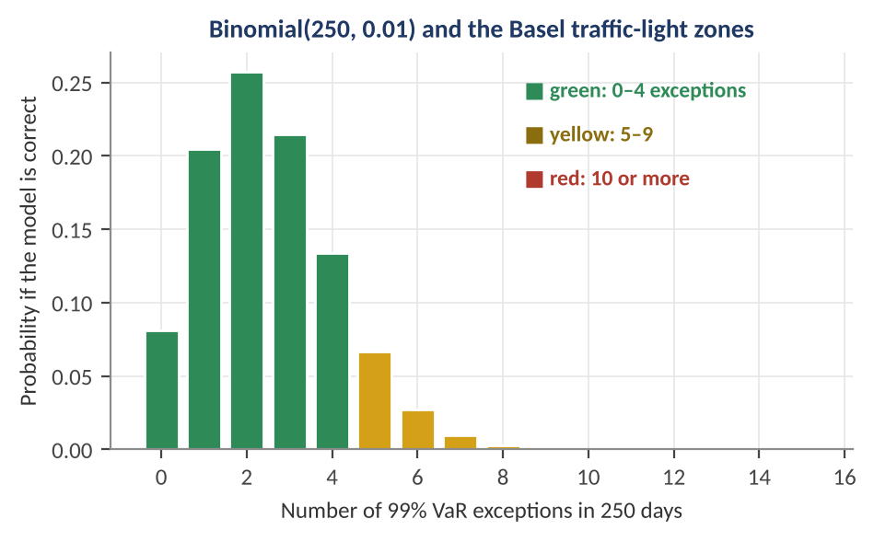
Figure 6.1 — The distribution of exception counts over 250 days for a correct 99% VaR model, coloured by Basel traffic-light zone. The green zone (0–4 exceptions) contains 89.2% of the probability; the yellow zone (5–9) 10.7%; the red zone (10 or more) only 0.025%.
Table 6.1 — The Basel traffic-light zones (99% VaR, 250 days)
Zone | Exceptions | Probability if model is correct | Regulatory response (internal-models multiplier add-on)
Green | 0–4 | 89.2% | None; the model is accepted
Yellow | 5–9 | 10.7% | Increasing add-on: 0.40, 0.50, 0.65, 0.75 and 0.85 for 5, 6, 7, 8 and 9 exceptions; supervisory judgement on causes
Red | 10 or more | 0.025% | Add-on of 1.00 (the maximum) and the model is presumed inaccurate

The traffic light is a rule of thumb. A statistically principled test of the same hypothesis is the Kupiec proportion-of-failures (POF) test, a likelihood-ratio test. With x exceptions in n days, observed rate p̂ = x / n, and the model's claimed rate p:
LR_{POF} = −2 ln[ (1 − p)^(n−x) · p^{x} ] + 2 ln[ (1 − p̂)^(n−x) · p̂^{x} ] ~ χ²(1)
A large LR (above 3.84 for a 5% test) rejects the claimed coverage. Because it compares the model's rate with the observed rate in both directions, it also detects a model that is too conservative.
Table 6.2 — Kupiec test results for a 99% VaR over 250 days
Exceptions x | Observed rate | LR statistic | p-value | Verdict at 5%
2 | 0.8% | 0.11 | 0.742 | Accept
4 | 1.6% | 0.77 | 0.380 | Accept
5 | 2.0% | 1.96 | 0.162 | Accept (yellow zone)
6 | 2.4% | 3.56 | 0.059 | Borderline accept
8 | 3.2% | 7.73 | 0.0054 | Reject
10 | 4.0% | 12.96 | 0.0003 | Reject

Worked example — A Kupiec calculation.
A trading desk records 8 exceptions in 250 days against a 99% VaR. Then p̂ = 0.032 and LR = −2 [ 242 ln 0.99 + 8 ln 0.01 ] + 2 [ 242 ln 0.968 + 8 ln 0.032 ] = 7.73. The 5% critical value of χ²(1) is 3.84, so the model is rejected (p = 0.0054). Note the asymmetry the regulators accepted: 5 exceptions are in the yellow zone but the Kupiec test does not reject them, because a model that is slightly wrong cannot be distinguished from a correct one by so few events.

Key idea — Backtests have low power.
Suppose the true exception rate is 2% (the model understates risk by half). Over 250 days the chance of a Kupiec rejection at the 5% level is only about 24%. The chance of at least five exceptions (yellow or red) is 56%, and of ten or more (red) only 3%. If the true rate is 3%, rejection probability rises to 62%. A one-year backtest therefore catches grossly wrong models and misses moderately wrong ones: failing to reject is not evidence of a good model. Longer samples, lower-quantile (for example 95%) checks that produce more exceptions, and complementary tests are the practical remedies.

6.3 Independence and Conditional Coverage
Level: Intermediate
A model can have exactly the right number of exceptions and still be badly wrong if they arrive in clusters. Figure 6.2 compares two VaR forecasts on the same 1,000 simulated days with time-varying volatility: a static VaR from the full-sample volatility, and a conditional VaR from an exponentially weighted moving average (EWMA, decay 0.94) that tracks changing risk.
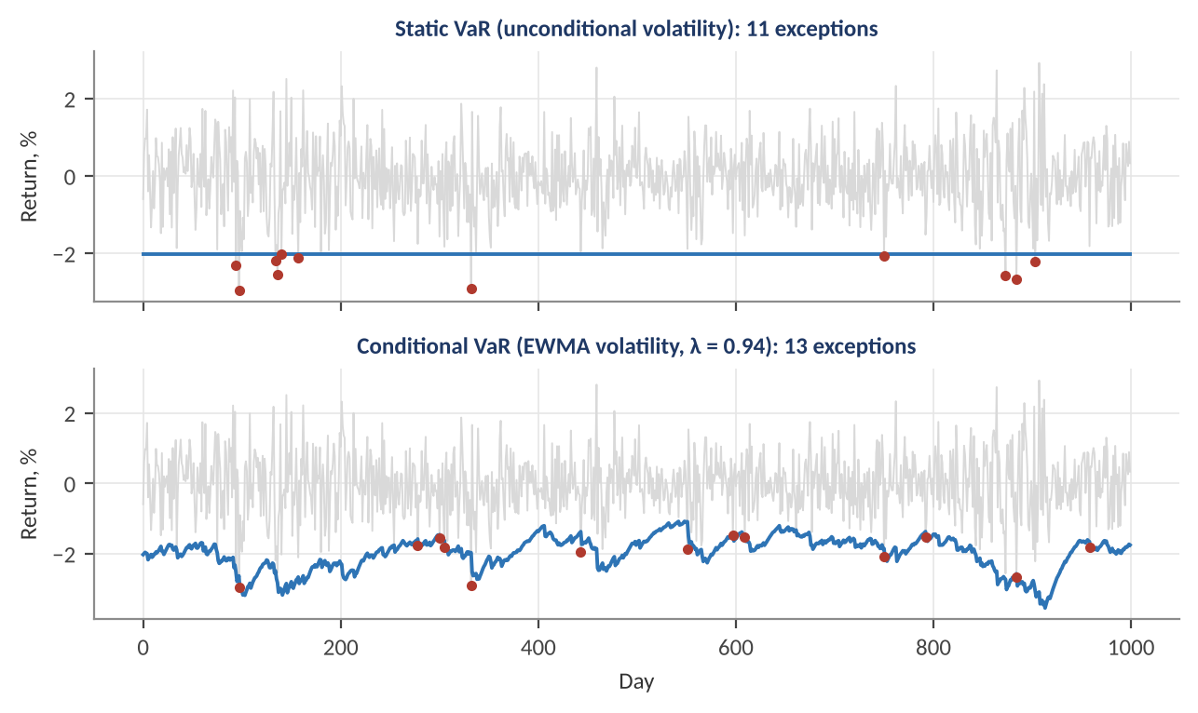
Figure 6.2 — Static versus conditional 99% VaR on 1,000 simulated days with volatility clustering. The static model has 11 exceptions, concentrated in volatile stretches (three pairs within five days of each other); the EWMA model has 13 exceptions, spread more evenly (one such pair). Counts alone barely distinguish them.
Both models pass the Kupiec test (p = 0.75 and 0.36), and a first-order independence test on consecutive days also passes for both, since with only 11–13 events almost none occur on adjacent days. The picture reveals what the count cannot: the static VaR fails exactly when markets are turbulent, and its large losses are the ones that matter. This is the reason to examine the timing of exceptions, not only their number.
The Christoffersen independence test formalises this. Count transitions between hit states: n₀₀ (no hit then no hit), n₀₁, n₁₀ and n₁₁. Estimate the probability of a hit after a non-hit, π₀₁ = n₀₁ / (n₀₀ + n₀₁), after a hit, π₁₁ = n₁₁ / (n₁₀ + n₁₁), and overall, π = (n₀₁ + n₁₁) / (n₀₀ + n₀₁ + n₁₀ + n₁₁). The statistic compares the two-state Markov likelihood with the single-probability one:
LR_{IND} = −2 ln[ (1 − π)^(n₀₀+n₁₀) π^(n₀₁+n₁₁) ] + 2 ln[ (1 − π₀₁)^{n}₀₀ π₀₁^{n}₀₁ (1 − π₁₁)^{n}₁₀ π₁₁^{n}₁₁ ] ~ χ²(1)
LR_{CC} = LR_{POF} + LR_{IND} ~ χ²(2) (conditional coverage)
Worked example — Clustered exceptions.
In 250 days a VaR model has 6 exceptions. Transition counts are n₀₀ = 239, n₀₁ = 4, n₁₀ = 4, n₁₁ = 2. After a normal day the chance of a hit is π₀₁ = 4/243 = 1.6%; but after a hit the chance of another is π₁₁ = 2/6 = 33%, twenty times higher. The independence statistic is LR_{IND} = 8.14 (p = 0.0043). Kupiec alone gives LR_{POF} = 3.56 (p = 0.059), which would pass. The combined conditional-coverage statistic is LR_{CC} = 3.56 + 8.14 = 11.69 (p = 0.0029 on two degrees of freedom): the model is rejected because its failures cluster, even though their count looked acceptable.

6.4 Expected Shortfall and Tail Validation
Level: Advanced
VaR says nothing about how bad losses are beyond the threshold. Expected shortfall (ES), the average loss on the days the VaR is breached, captures tail severity and has replaced VaR as the main market-risk measure in recent Basel rules:
ES_{p} = E[ −r_{t} | r_{t} < −VaR_{t}(p) ]
Worked example — ES versus VaR.
For normally distributed returns with daily volatility 1%, the 99% VaR is 2.33% and the 99% ES is 1% × φ(2.326) / 0.01 = 2.67%. If the real tail is fatter and the exceptions on the desk average a 4.2% loss, a VaR-only backtest would see a normal number of exceptions, while the model's ES understates the true tail loss by more than 35%. ES backtesting looks at the size of the exceedances as well as their count.

ES is harder to backtest. It is not elicitable on its own (no scoring rule has it as its unique minimiser), although VaR and ES jointly are, so scoring-rule approaches and tests such as Acerbi–Székely compare the realised tail losses with the model's predicted tail distribution. In practice, banks combine several checks:
- Exception counts at several levels — the Basel desk-level test for the revised framework counts exceptions at both 99% and 97.5% (a desk with more than 12 and 30 exceptions respectively over 250 days fails), because the lower level produces more events and so more power.
- Severity of exceptions — the average and maximum exceedance relative to VaR; a model whose exceptions are all modest overshoots is better than one with a few catastrophic ones.
- Quantile (pinball) loss — for a forecast quantile q at level p, the loss (p − 1{r < q})(r − q) is minimised in expectation by the true quantile, and lets you compare competing VaR models on a single score.
- Dynamic quantile and regression tests — regress the hit indicator on lagged hits and on the VaR forecast itself; under correct specification, nothing should predict hits.
Common mistake — Backtesting on the wrong P&L.
VaR is usually computed on a hypothetical portfolio (holdings fixed at the start of the day, no intraday trading, no fees). Comparing it with actual P&L, which includes intraday trading, commissions, funding, and reserves, mixes two different quantities. Regulators require both: a clean (hypothetical) backtest to test the model, and an actual backtest to test the outcome that reaches the desk. When they disagree, the explanation — position changes, fees, data — is itself a validation finding.

6.5 Validating a Whole Distribution: The Probability Integral Transform
Level: Advanced
A volatility or return model usually forecasts a full distribution F_{t}, not only one quantile. The probability integral transform (PIT) gives a model-free calibration check: for each realised return r_{t}, compute u_{t} = F_{t}(r_{t}), the model's own cumulative probability of what actually happened. If the forecast distributions are correct, the u_{t} are independent and uniform on [0, 1]. A histogram of PIT values reveals the nature of any miscalibration (Figure 6.3).
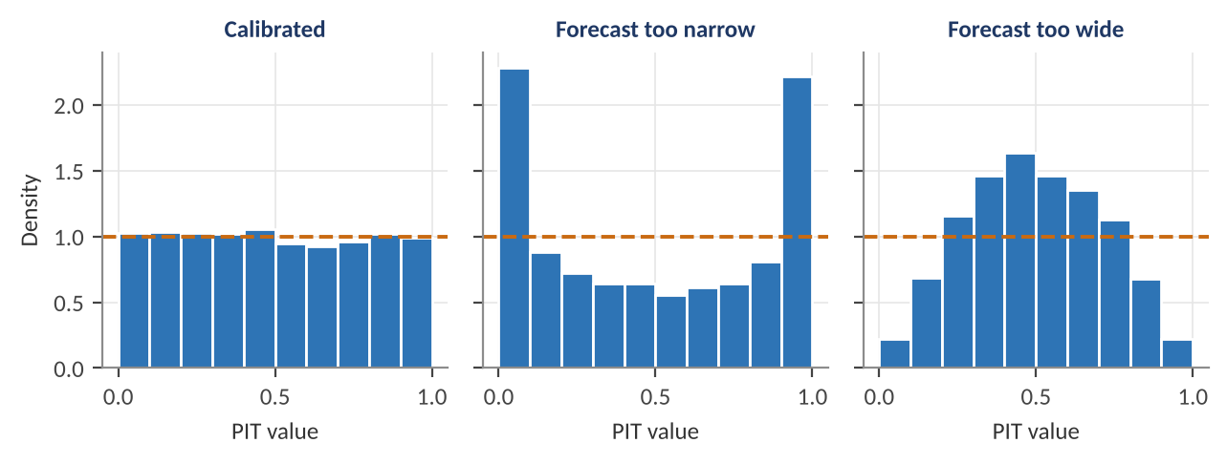
Figure 6.3 — PIT histograms for three forecasts of the same data. Left: a calibrated forecast gives a flat histogram. Middle: a forecast that is too narrow produces a U-shape — too many realisations in the extreme tails. Right: a forecast that is too wide produces a hump — too few in the tails.
- U-shape — realisations land too often in the tails: the model is overconfident (variance too low or tails too thin), the typical failure of a normal model on fat-tailed returns.
- Hump — realisations cluster in the middle: the model is underconfident (too wide).
- Slope — the forecast is biased: realisations tend to be above or below the predicted centre.
- Formal tests — Kolmogorov–Smirnov or Anderson–Darling tests on uniformity, and the Berkowitz test, which transforms the PIT values to a standard normal and tests mean, variance, and autocorrelation jointly.
Tip — Test the forecast you actually use.
A model may be well calibrated unconditionally but badly calibrated in high-volatility states. Split the PIT analysis by volatility regime, by asset, and by horizon. A risk number that is right on average and wrong when it matters is not fit for its purpose.

Part 7 — Validating Pricing, Simulation and Forecasting Models
Pricing and simulation models have an advantage that alpha models lack: for many of them there is a known right answer to compare against. This part covers verifying that a pricing model is implemented correctly, measuring numerical error, testing calibration and hedging performance, and evaluating forecasts and probabilities with proper scoring rules.

7.1 Verification: Is the Code Doing What the Specification Says?
Level: Beginner → Intermediate
Verification asks whether the model is implemented correctly; validation asks whether the model is right for the purpose. Verification comes first, because a conceptual error and a coding error look identical in the output. The standard toolkit has four elements:
- Independent re-implementation — a second person or a separate code path reproduces the results from the written specification. Agreement to numerical tolerance is strong evidence; disagreement locates the bug.
- Benchmarks with known answers — compare with closed-form solutions, published values, or a trusted library in special cases where they exist.
- No-arbitrage and consistency checks — identities that any valid price must satisfy, regardless of the model.
- Limit and boundary tests — extreme inputs (zero volatility, zero maturity, deep in or out of the money) have known behaviour, and many implementations break there.
Worked example — Verifying an option pricer against Black–Scholes.
A new pricer values a one-year European option with S = 100, K = 100, r = 5% and volatility 20%. The Black–Scholes benchmark gives call = 10.4506 and put = 5.5735. Put–call parity requires C − P = S − K e^(−rT) = 100 − 95.1229 = 4.8771, and 10.4506 − 5.5735 = 4.8771 matches exactly. The Greeks have closed forms (delta 0.6368, gamma 0.01876, vega 37.52 per unit of volatility, i.e. 0.3752 per volatility point), so finite-difference bumps give an independent check: (C(101) − C(99)) / 2 = 0.6367 for delta, 0.01876 for gamma, and 0.3752 for vega per point. All agree to four decimals. If the pricer's delta differed by 1%, a hedging error would accumulate on every trade, even though the price itself looked right.

- Unit tests with known answers — zero-volatility options equal discounted intrinsic value; a deep in-the-money call equals the forward minus the discounted strike; price is monotone in volatility and convex in strike.
- Regression tests — store the outputs of a validated version, and fail the build if a code change shifts any benchmark result beyond tolerance.
- Input and data validation — reject negative volatilities, stale curves, and unsorted strikes before they reach the model.

7.2 Numerical Error: Simulation Noise and Discretisation
Level: Intermediate
Many models have no closed form and are solved numerically: Monte Carlo simulation, finite-difference grids, binomial trees. Their answers contain numerical error that is separate from model error and can be measured. For Monte Carlo, the price estimate is an average of N independent discounted payoffs, so by the central limit theorem its standard error is:
SE = σ_{payoff} / √N
Error falls with the square root of the number of paths, so halving the error needs four times as many paths, and ten times more precision needs a hundred times more. Figure 7.1 shows this on the option above, where the exact answer is known.
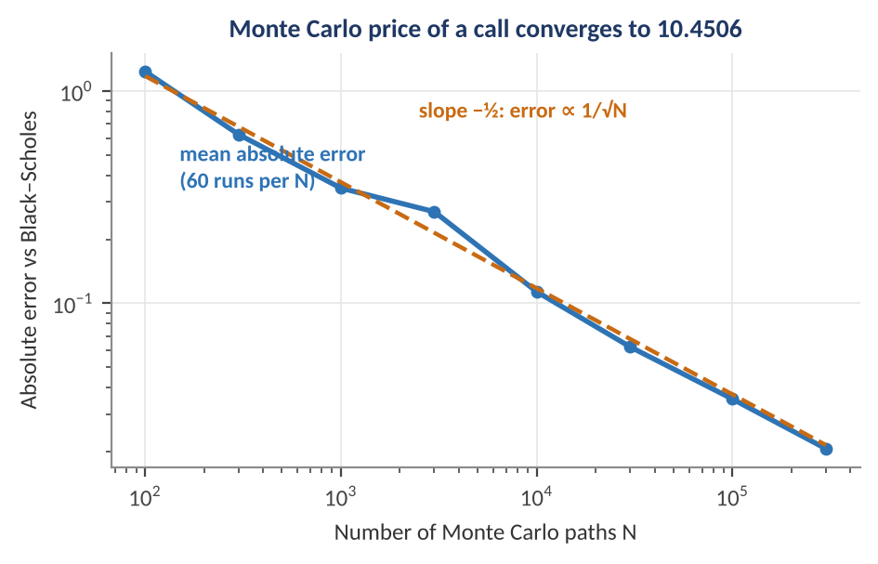
Figure 7.1 — Monte Carlo error for the one-year call price against the number of paths. Each point averages 60 independent runs. The error falls along the slope −½ line: 100 paths give an average error of about 1.2, and 300,000 paths about 0.02.
Worked example — Choosing the number of paths.
The discounted payoff of the call has a standard deviation of about 14.70. With N = 10,000 paths, SE = 14.70 / 100 = 0.147; a 95% confidence interval is the estimate ± 0.29, which is nearly 3% of the 10.45 price. With N = 1,000,000, SE = 0.0147. A single run with a million paths returned 10.4276, which is 0.0230 below the exact 10.4506, about 1.6 standard errors: consistent with pure simulation noise. A validator reports the standard error alongside every Monte Carlo price, and requires the number of paths to be large enough that the noise is well below the smallest price move that matters (for example, a tenth of a basis point of notional).

Other numerical errors are systematic rather than random. Discretisation error arises from replacing a continuous process by time steps (an Euler scheme with few steps biases barrier and path-dependent prices), and grid error from coarse finite-difference meshes. Test them by convergence analysis: refine the step size or grid and confirm that the answer converges at the expected rate (for example, error halving or quartering with each doubling), and that the converged value agrees with a benchmark. Variance-reduction techniques (antithetic variates, control variates, quasi-random numbers) reduce noise, but themselves need validation, since a mistake in a control variate introduces bias that the standard error will not reveal.

7.3 Calibration and Hedging Tests
Level: Advanced
Pricing models usually have parameters calibrated so that model prices match observed market prices of liquid instruments. A model that fits the calibration set perfectly can still be wrong, in the same way a regression with enough parameters fits any data. Three tests probe whether the fit means anything:
- Out-of-sample calibration — calibrate on a subset (for example, near-the-money options) and test on instruments not used (deep out-of-the-money strikes, longer maturities), or calibrate on one day and price the next.
- Parameter stability — a model whose calibrated parameters jump from day to day, or take implausible values, is compensating for misspecification. Track parameters over time and compare their stability with the stability of the market.
- Hedging performance — the ultimate test of a pricing model is that the replicating portfolio it implies actually replicates. Simulate or observe delta hedging and measure the distribution of the P&L at expiry.
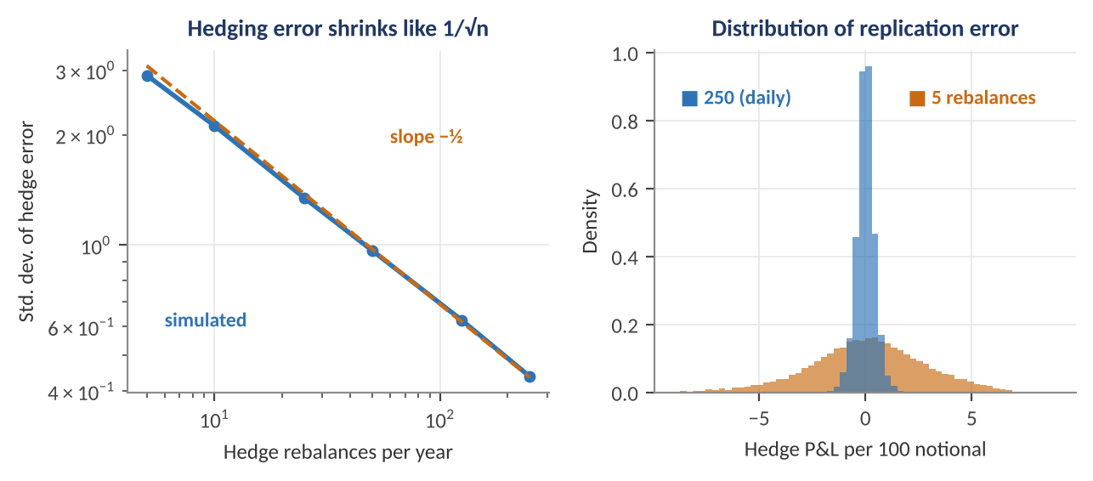
Figure 7.2 — Delta-hedging a one-year at-the-money call (price 10.45) in a market that follows the Black–Scholes model exactly. Left: the standard deviation of the hedge error falls like 1/√n with the number of rebalances n. Right: with 5 rebalances the replication error is wide (std. dev. 2.9, nearly 28% of the premium); with daily rebalancing it is 0.44, about 4%.
Worked example — Reading the hedging test.
Even when the model is perfectly specified, discrete hedging leaves a replication error that shrinks as the number of rebalances grows: standard deviation of about 2.9 with 5 rebalances, 1.3 with 25, and 0.44 with 250. The mean error is close to zero in every case, as it should be. The validation benchmark is therefore not 'zero error' but the error predicted by the model's own assumptions: if observed hedging errors on real data are much larger than the simulation implies, or have a nonzero mean, the model is missing something — jumps, stochastic volatility, or transaction costs.

Common mistake — Treating a good in-sample fit as validation.
Fitting a model with enough free parameters to every price on the screen is interpolation, not evidence of the model's truth. The question for a validator is what the model says about things that were not fitted: hedge ratios, prices of exotic structures, behaviour after a market move. A model that fits today's smile but predicts tomorrow's smile worse than a naive 'same as today' benchmark has no business pricing risk.

7.4 Evaluating Forecasts: Loss Functions and Tests
Level: Intermediate
Forecasts of returns, volatility, or correlations are evaluated by comparing them with realised values through a loss function. The choice of loss matters: ranking models by a loss that does not match the purpose can select the wrong model. The common losses are:
Table 7.1 — Common forecast loss functions
Loss | Formula | When to use it
Squared error (MSE) | (y − f)² | Mean forecasts; penalises large errors heavily
Absolute error (MAE) | |y − f| | Robust to outliers; median forecasts
QLIKE | y/f − ln(y/f) − 1 | Variance forecasts; robust to noise in the volatility proxy
Pinball (quantile) loss | (p − 1{y < f})(y − f) | Quantile forecasts such as VaR
Log score | −ln(predicted density at y) | Full distribution forecasts
Brier score | (f − y)² with y in {0, 1} | Probability forecasts of events

Volatility forecasts are compared with a noisy proxy (squared returns or realised variance), so only certain losses — MSE and QLIKE — give a consistent ranking whatever the noise. The Mincer–Zarnowitz regression checks whether a forecast is unbiased and efficient by regressing the outcome on the forecast:
y_{t} = a + b · f_{t} + ε_{t} (an unbiased forecast has a = 0 and b = 1)
A slope b below 1 says the forecast is too extreme (it should be shrunk toward the mean), and above 1 says it is too timid. The out-of-sample R² introduced in the Macroeconomics module compares a model with a benchmark, and the Diebold–Mariano test tests whether the difference between two models' losses is statistically different from zero:
DM = d̄ / ( s_{d} / √n ), d_{t} = L(model A)_{t} − L(model B)_{t}
Worked example — Is model A really better?
Two volatility models are compared over 250 days using QLIKE. Model A has a lower average loss: the mean daily loss difference is d̄ = 0.012, with a standard deviation of the daily differences s_{d} = 0.15. Then DM = 0.012 / (0.15 / √250) = 0.012 / 0.00949 = 1.26, below the 1.96 needed at the 5% level. The improvement is within noise: with this much variability in the daily losses, a gap of this size would arise by chance roughly one time in five. In practice the daily differences are autocorrelated, so the standard deviation should use a Newey–West (HAC) correction, which widens the interval further.

Tip — Compare against a naive benchmark.
A forecast is only as good as its improvement over the obvious alternative: yesterday's value, a long-run average, an EWMA, or a random walk. A complex model that cannot beat a naive benchmark out of sample should not be put into production, however sophisticated its construction.

7.5 Probability Forecasts and Calibration
Level: Intermediate → Advanced
Many quantitative models output a probability: the chance a default occurs, a recession begins, or a stock outperforms. These are validated on two separate properties. Discrimination is the ability to rank outcomes (do higher forecasts go with more events?), measured by the ROC curve and AUC. Calibration is whether the numbers are honest (do events forecast at 70% occur about 70% of the time?). A model can discriminate well and be badly calibrated, and for decisions that use the probability as an input — position sizes, loss provisions, capital — calibration is the property that matters.
The Brier score is the mean squared difference between the forecast probability f and the outcome y (1 if the event occurred, 0 otherwise); lower is better. A reliability diagram groups forecasts into bins and plots the observed frequency in each bin against the average forecast:
Brier = (1/n) Σ (f_{i} − y_{i})²
Worked example — A five-forecast Brier score.
Forecast probabilities of 0.9, 0.8, 0.3, 0.6 and 0.2 are compared with outcomes 1, 1, 0, 0 and 0. The squared errors are 0.01, 0.04, 0.09, 0.36 and 0.04, which average 0.108. A constant forecast equal to the base rate (here 0.4) would score 0.24, so the model is informative. The large 0.36 term comes from the confident wrong forecast of 0.6 for a non-event: the Brier score penalises overconfidence heavily.

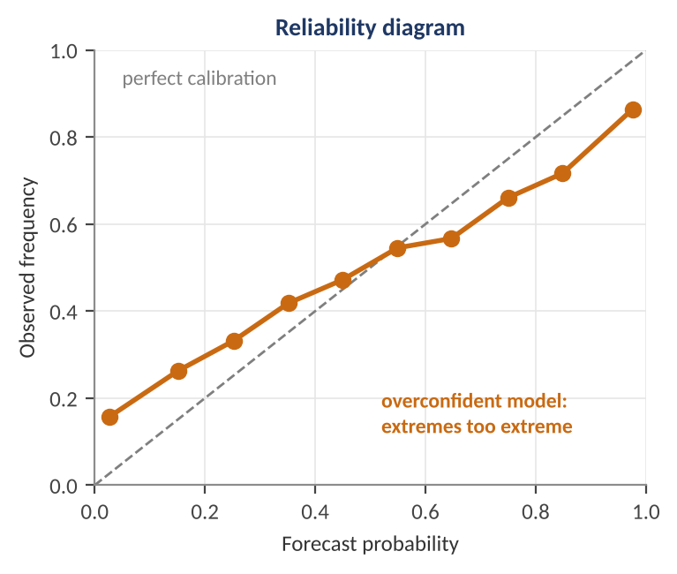
Figure 7.3 — A reliability diagram for an overconfident probability model on 6,000 simulated cases. Points below the diagonal at high forecasts and above it at low forecasts show that the model's extreme probabilities are more extreme than the observed frequencies. Its Brier score is 0.206 versus 0.197 for the true probabilities.
In this simulation the model ranks cases correctly but exaggerates the spread of its forecasts. The remedy is recalibration: fit a monotone mapping from raw scores to probabilities (Platt scaling, a logistic regression of the outcome on the score, or isotonic regression) on a validation set, then verify on a separate test set. Fitting the recalibration on the test set would reuse it, a leak of the kind described in Part 5.

Part 8 — Signal Validation, Robustness, Stress Tests and Drift
Parts 2 to 5 tested whether a strategy's performance is real. This part goes behind the P&L to the signal itself, asks whether the result would survive a different ordering of events, a different regime, or a severe scenario, and shows how to detect that the world has changed since the model was built.

8.1 Information Coefficient and Quantile Analysis
Level: Intermediate
A trading signal is only useful if it ranks assets by their future returns. The information coefficient (IC) measures this directly: at each date, take the cross-sectional rank correlation (Spearman) between the signal and the subsequent return across assets:
IC_{t} = Spearman( signal_{i,t} , return_{i,t+1} ) across assets i
Averaging IC across dates gives the signal's average predictive power. The ratio of the mean IC to its standard deviation, the IC information ratio (IC-IR), measures its consistency. The fundamental law of active management links these to the achievable risk-adjusted return:
IR ≈ IC × √BR
where BR (breadth) is the number of independent bets per year. The law makes a sobering point: a tiny IC is enough if it is applied across many independent bets, and a large IC on a handful of correlated bets is not.
Worked example — The fundamental law.
A signal with IC = 0.05 applied to 250 independent bets a year has IR ≈ 0.05 × √250 = 0.79; applied across 1,000 independent bets, IR ≈ 1.58. The important word is independent: 1,000 stocks that are all driven by the same market factor are not 1,000 bets, and the effective breadth may be a small fraction of the nominal count. Validation therefore reports not only the IC but also its stability across dates and sub-universes.
A small ranking illustration of the IC itself: for ten stocks, signal ranks 1 to 10 and next-period returns of 0.5, −0.2, 0.1, 0.4, 0.0, 0.8, 0.3, 1.0, 0.6 and 1.1 (%) give a Spearman IC of 0.67. A single-date IC of that size is easy to get by luck with ten names, which is why the IC is always averaged over many dates.

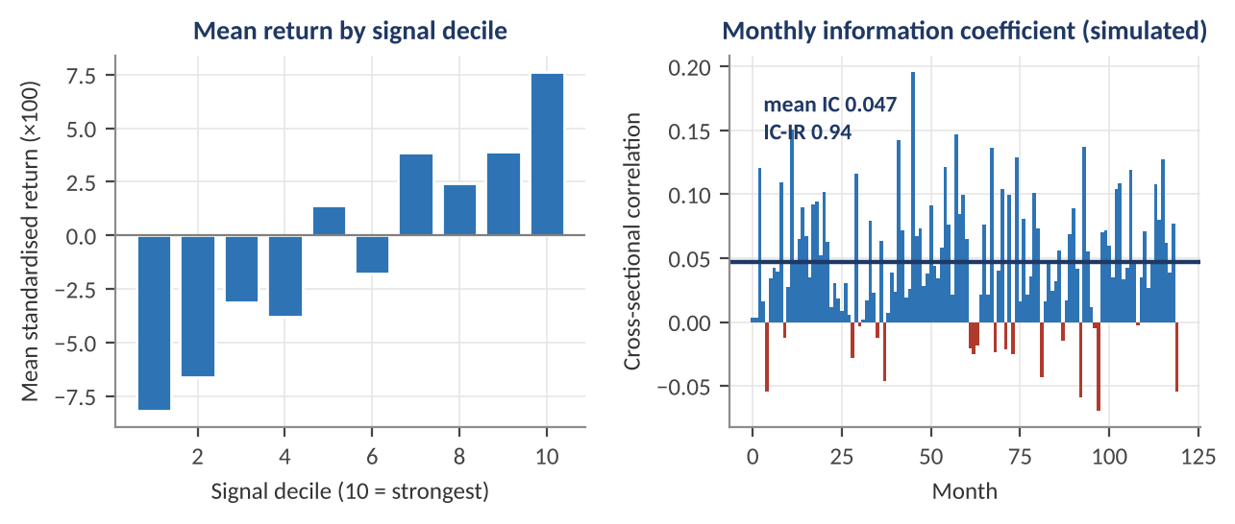
Figure 8.1 — A simulated signal with a true IC of about 0.05 over 120 months and 300 stocks. Left: mean standardised return by signal decile rises from the bottom to the top (the top-minus-bottom spread is 0.16 standard deviations). Right: monthly IC is positive in about 84% of months; the mean IC is 0.047, with an IC-IR of 0.94.
Worked example — Is a mean IC significant?
In the simulation above the mean IC is 0.0468 and its standard deviation across months is 0.0498, over 120 months. The standard error of the mean is 0.0498 / √120 = 0.00455, so t = 0.0468 / 0.00455 = 10.3. Be careful: this assumes monthly ICs are independent. With 12-month overlapping returns or highly persistent signals they are not, and the effective number of observations may be a fifth of the nominal. A t-statistic of 10 survives that adjustment; one of 2.5 may not.

A quantile (decile) analysis complements the IC: sort assets into groups by signal value and plot the average subsequent return of each group. A genuine signal shows a monotonic pattern across the groups; a signal that works only in the extreme tail or has a non-monotonic shape is fragile or reflects a few outliers. Three further checks belong in a signal report:
- IC decay — compute the IC against returns 1, 2, 5, 10 and 20 periods ahead. Rapid decay means the signal needs fast trading and is expensive to capture; slow decay allows lower turnover.
- Turnover and cost-adjusted IC — the signal's autocorrelation determines how much trading it creates; a high-IC signal that flips every day may not survive costs.
- Neutralisation — check that the signal's performance is not just exposure to a known factor (market, size, value, sector). Regress returns on the signal after controlling for those exposures.

8.2 Permutation and Reshuffling Tests
Level: Intermediate → Advanced
Resampling can build a null distribution from the data itself, without assuming normal returns. In a permutation test for a signal, you destroy any real relationship by randomly shuffling the signal values relative to returns (preserving the signal's distribution and the returns' distribution), recompute the performance statistic, and repeat hundreds or thousands of times. The observed statistic is then compared with this null distribution:
p-value = ( 1 + #{ permutations with statistic ≥ observed } ) / ( 1 + B )
Worked example — A permutation p-value.
A strategy has an observed Sharpe ratio of 1.2. After randomly shuffling the signal 999 times and recomputing the Sharpe ratio each time, 12 of the shuffled strategies achieve a Sharpe of 1.2 or more. The p-value is (1 + 12) / (1 + 999) = 0.013. The shuffle must respect the structure of the data (shuffle whole blocks or within regimes if returns are autocorrelated, and shuffle signal labels within each date for cross-sectional signals) or the null is too easy to beat.

A second kind of resampling reshuffles the order of realised trades or returns to ask how much of the backtest's path was luck. A strategy's maximum drawdown depends on the sequence in which wins and losses happened, but the same trades in a different order would have produced a different drawdown. Reshuffling gives the distribution of drawdowns that the same trading edge could have produced (Figure 8.2).
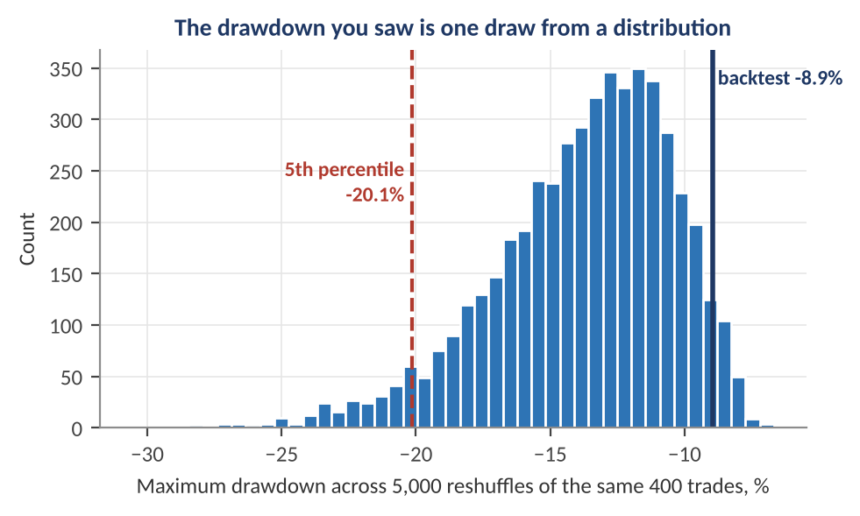
Figure 8.2 — The maximum drawdown of 400 simulated trades, reshuffled 5,000 times. The backtest's actual drawdown of −8.9% (navy) was better than 96% of the reshuffled orderings; the median is −13.2% and the 5th percentile −20.1% (red). A risk budget built on the −8.9% would be too small.
Understand before proceeding — Plan for the typical bad path, not the lucky one.
The backtest's drawdown is one draw from a wide distribution. In this example the realised path was unusually benign: 96% of orderings of the same trades produced a deeper drawdown, and one in twenty exceeded 20%. Sizing, leverage limits, and investor communication should be based on a high percentile of the reshuffled distribution (for example, the 5th), not on the single historical value. The same logic applies to the length of the longest losing streak and the time under water.

8.3 Robustness Across Sub-Periods, Regimes and Markets
Level: Intermediate
A strategy with a positive overall Sharpe ratio may get all of it from one episode. Robustness analysis slices the sample to see how performance is distributed:
Table 8.1 — Robustness slices and what they reveal
Slice | How to do it | What a failure tells you
Sub-periods | Report performance by calendar year, by decade, and by halves of the sample | Profits concentrated in one year imply dependence on a single event
Rolling window | Plot a 12–36 month rolling Sharpe ratio and the cumulative curve | Long flat or negative stretches mean the strategy is dormant or decayed
Volatility and macro regimes | Condition on high/low volatility, growth/inflation regimes (Macroeconomics Part 5), rising/falling rates | A hidden exposure to a regime; the strategy may be a regime bet rather than an edge
Cross-section | Split the universe by size, sector, country, or liquidity | Performance only in illiquid small caps means capacity and costs will erase it
Other markets | Apply the same unchanged rules to related markets or to non-overlapping data | Poor transfer suggests the rule was fitted to one series
Leave-one-out | Remove the best year, the best asset, or the best 1% of days and recompute | A strategy that disappears without its top days is a collection of outliers

Worked example — Dropping the best days.
A strategy earns 12% a year with a Sharpe ratio of 0.9. When the best 10 days out of 2,500 (0.4% of the sample) are removed, the return falls to 3% and the Sharpe ratio to 0.25. Three-quarters of the profit came from 0.4% of the days. That is not necessarily disqualifying — trend-following strategies earn most of their return from a few large moves — but it must be known, because it changes the capacity to bear the long periods in which no such days arrive, and the cost of missing them through a delay or an outage.

8.4 Stress Tests and Scenario Analysis
Level: Intermediate
Backtests and risk models describe the world as sampled. Stress tests ask what happens in worlds that were not sampled or were rare. There are three common designs:
- Historical scenarios — replay a past episode (a market crash, a rate shock, a liquidity crisis, a currency devaluation) on the current portfolio.
- Hypothetical scenarios — specify a coherent shock set from economic reasoning: equities −20%, credit spreads +150 bp, rates +100 bp, volatility doubling, dollar +10%.
- Reverse stress tests — start from a loss that would be unacceptable and search for the market moves that produce it, revealing the portfolio's true vulnerabilities.
A first-order estimate of the portfolio's loss from a shock Δx_{i} to each risk factor i uses the factor sensitivities, with a second-order term where non-linearity matters:
ΔP ≈ Σ_{i} Δ_{i} · Δx_{i} + ½ Σ_{i} Γ_{i} · (Δx_{i})²
Worked example — A simple scenario loss.
A $100m portfolio has an equity beta of 0.8 and a rates exposure of −$50,000 per basis point (DV01). A hypothetical scenario of equities −20% and rates +100 bp costs 0.8 × (−20%) × $100m = −$16m on the equity exposure and −$50,000 × 100 = −$5m from rates, a total of −$21m, or 21% of the portfolio, if the two effects simply add. The result depends on how the risks interact: if the rate rise accompanies the equity fall, as in an inflation shock, they compound; if rates fall in the equity sell-off, as in a growth scare, the rates exposure may offset part of the loss. The scenario must be internally consistent — stress tests that shock every factor in its worst direction at once are not plausible and produce unusable answers.

- Correlations change in stress — assets that diversify in calm markets often fall together in a crisis; scenarios should specify the joint move, not apply historical correlations to a large shock.
- Liquidity matters — a stressed market means wider spreads and slower exits; include a liquidity horizon and the cost of unwinding positions.
- Model validity at the extremes — a pricing or risk model validated in normal conditions may fail under stress; test it there explicitly.

8.5 Detecting Drift: Has the World Changed Since the Model Was Built?
Level: Intermediate → Advanced
A model is estimated on one distribution of inputs and used on another. Three kinds of change are worth distinguishing: data drift (the distribution of the inputs changes), label or outcome drift (the distribution of the target changes), and concept drift (the relationship between inputs and outcome changes). Data drift can be measured without waiting for outcomes, which makes it an early warning.
The population stability index (PSI) compares the share of observations in each bin of a variable at training time (expected, e_{i}) with the share today (actual, a_{i}):
PSI = Σ_{i} ( a_{i} − e_{i} ) · ln( a_{i} / e_{i} )
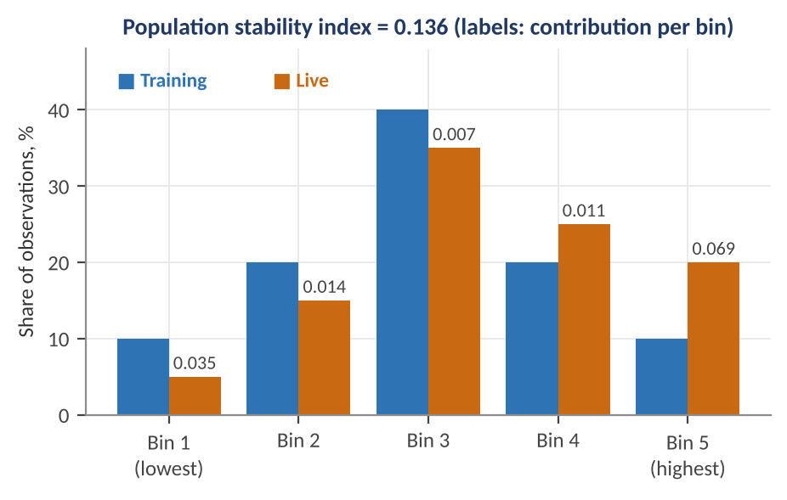
Figure 8.3 — PSI for a feature divided into five bins. Live data (orange) has shifted toward the highest bin relative to training (blue), giving a PSI of 0.136, in the moderate-shift range. The numbers above the orange bars are each bin's contribution.
Worked example — Computing PSI.
A feature is split into five bins that held 10%, 20%, 40%, 20% and 10% of the training data. In live data the shares are 5%, 15%, 35%, 25% and 20%. The bin contributions are (0.05 − 0.10) ln(0.5) = 0.0347, (0.15 − 0.20) ln(0.75) = 0.0144, (0.35 − 0.40) ln(0.875) = 0.0067, (0.25 − 0.20) ln(1.25) = 0.0112, and (0.20 − 0.10) ln(2.0) = 0.0693. The total is PSI = 0.136. A common convention reads values below 0.10 as stable, 0.10 to 0.25 as a moderate shift that deserves investigation, and above 0.25 as a significant shift that calls for revalidation. Those thresholds are rules of thumb from credit scoring, not statistical tests; for a formal test use the Kolmogorov–Smirnov test for continuous variables or a chi-squared test across bins.

- Monitor features and predictions — drift in the distribution of the model's output is often the most sensitive single indicator.
- Separate benign from harmful drift — a feature may drift (volatility rises) without affecting the model's accuracy, and a relationship may break (concept drift) with no visible change in any input distribution. Pair PSI with outcome monitoring (Part 9).
- Set action rules in advance — what PSI level triggers an investigation, what triggers a recalibration, and what triggers a halt.

Part 9 — Live Validation, Monitoring and Model-Risk Governance
Validation does not end when a model is approved. Live markets are the only genuinely out-of-sample test, and they arrive slowly. This part covers how to move a strategy from research into production in stages, how to monitor it statistically, and how organisations govern the many models they run so that errors are found by design rather than by loss.

9.1 Incubation, Paper Trading and the Capital Ramp
Level: Beginner → Intermediate
Before a strategy receives full capital, it should pass through stages that each answer a different question. The staged process of Figure 9.1 treats every gate as a place where the strategy can fail and be sent back, retired, or shrunk.
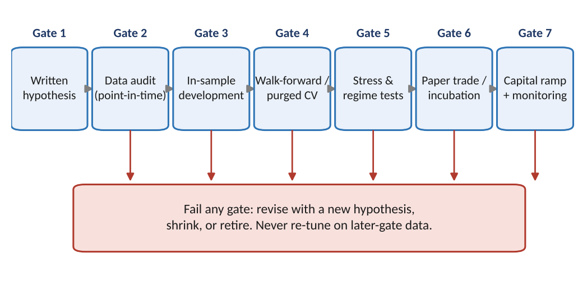
Figure 9.1 — A staged path from idea to full capital. Each gate tests something the previous one cannot: the data, the in-sample logic, the out-of-sample behaviour, extreme conditions, and finally real execution. Failing a gate sends the idea back with a new hypothesis, never into more tuning on data from later gates.
- Gate 1 — written hypothesis. The economic reason, expected sign, magnitude, and the tests to be run are recorded before the results.
- Gate 2 — data audit. Point-in-time data, correct corporate actions, delisted securities, survivorship, and timestamp alignment are verified.
- Gate 3 — in-sample development. Parameters are chosen with a count of trials kept (Parts 4 and 5).
- Gate 4 — walk-forward or purged cross-validation. The performance estimate used for decisions comes from here (Part 2).
- Gate 5 — stress and regime tests (Part 8).
- Gate 6 — paper trading or incubation. The live signal is generated and recorded in real time, without capital, to verify that the production pipeline reproduces the research results, with true timestamps and no hindsight.
- Gate 7 — capital ramp. Capital is increased in steps with pre-agreed monitoring criteria; early live losses are compared with what the backtest would have predicted, and execution costs are compared with assumptions.
Live performance is a weak test of the edge, because live samples are short. The point of the early live stage is mainly implementation validation — does the live system reproduce the backtest trade for trade? — rather than a verdict on the strategy's Sharpe ratio. For that, compare live and simulated trades and costs directly: fill prices against assumed prices (slippage), positions held against positions intended, and signal values computed live against values recomputed from archived data.
Worked example — One year of live data can't confirm or refute an edge.
A backtest shows an annualised Sharpe ratio of 1.0. After one year live, the realised Sharpe ratio is 0.2. Is the strategy broken? The standard error of a one-year Sharpe ratio is about √((1 + 0.5 × 1.0²) / 1) = 1.22, so the shortfall is (0.2 − 1.0) / 1.22 = −0.65 standard errors, an entirely ordinary outcome (a two-sided p-value of about 0.51) that is perfectly consistent with a true Sharpe ratio of 1.0. Equally, it cannot reject a true Sharpe ratio of zero. To distinguish a true Sharpe of 1.0 from zero at the 5% level, you need about 1.96² ≈ 3.8 years of live data. This is the reason to monitor mechanisms (slippage, signal agreement, exposures) and use statistical process control, rather than waiting for the Sharpe ratio to speak.

9.2 Statistical Monitoring and Kill-Switches
Level: Intermediate → Advanced
Statistical process control, borrowed from manufacturing, is a better fit than periodic reviews of the Sharpe ratio because it accumulates evidence continuously and has explicit false-alarm rates. The classic tool is the CUSUM (cumulative sum) chart. For a strategy with expected per-period return μ₀ and volatility σ, define standardised shortfalls and accumulate them, resetting at zero when performance is fine:
S_{t} = max( 0 , S_{t−1} + (μ₀ − x_{t}) / σ − k ) alarm when S_{t} > h
The allowance k (often half the size of the shift you want to detect, in standard-deviation units) stops noise from accumulating, and the threshold h sets the trade-off between false alarms and delay. The average run length (ARL) — the expected number of periods to an alarm — is the design target: a long ARL when the strategy is healthy (few false alarms) and a short one when it has deteriorated.
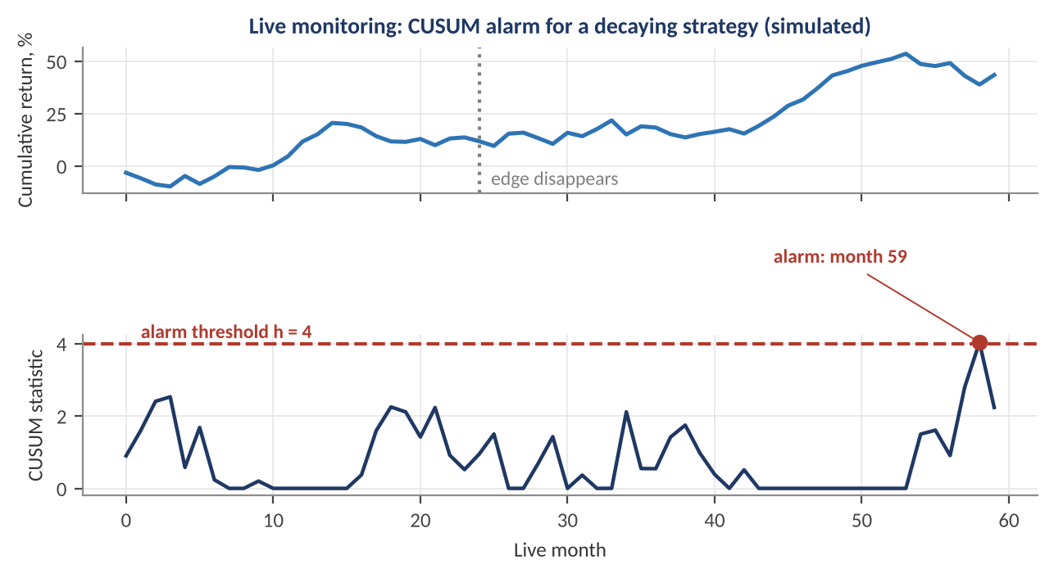
Figure 9.2 — A simulated strategy with an annualised Sharpe ratio of 1.0 whose edge disappears after month 24 (dotted line). The CUSUM statistic (bottom) accumulates standardised shortfalls and crosses the threshold h = 4 at live month 59, 35 months after the edge vanished.
Understand before proceeding — Detection is slow when the edge is small.
In Figure 9.2 the cumulative return looks reassuring for a long time after the edge is gone, because monthly noise of 2.9% dwarfs the monthly edge of 0.8%. The CUSUM alarm arrives after 35 months, which is early relative to waiting for a conventional significance test, but still long. This is the reality of low-signal strategies: monitoring cannot detect decay faster than the statistics allow. The practical conclusions are to monitor at the highest frequency that is meaningful (daily rather than monthly if the data are daily), to combine P&L monitoring with leading indicators of decay, and to keep risk and position limits tight enough that a decayed strategy cannot do large damage during the detection delay.

Table 9.1 — What to monitor in a live strategy
Category | Metrics | Typical action when breached
Performance | Rolling return, Sharpe, drawdown, CUSUM statistic versus expectation | Review; reduce size; investigate cause
Implementation | Slippage versus assumed cost, fill rates, latency, signal agreement between research and production | Fix infrastructure; update cost model
Exposures | Beta, factor, sector, country, leverage, concentration, liquidity | Rebalance; reduce positions
Inputs | PSI and distribution checks, missing or stale data, outliers, vendor changes | Pause signal; fall back to a safe default
Model outputs | Distribution of forecasts, hit rates, calibration, turnover | Recalibrate; revalidate
Risk limits | Daily loss, VaR usage, position and drawdown limits | Automatic reduction or halt (kill-switch)

A kill-switch is a pre-agreed automatic rule that reduces or halts trading when a limit is breached, designed so that it does not depend on anyone's judgement in the moment. Good designs share three properties: the thresholds are set in advance from the distribution of normal outcomes (for example, a daily loss beyond what the model says is a one-in-a-thousand event); the action is graded (reduce, then halt); and the restart procedure is also defined, because a switch that no one dares reset or that is overridden under pressure is no control.
Common mistake — Stopping a strategy on a drawdown that was in the plan.
If the reshuffling analysis of Part 8 says a 15% drawdown happens about once in three years for a healthy strategy, a 15% drawdown is not by itself evidence of failure, and shutting the strategy down at that point converts normal variation into permanent losses. Distinguish risk-limit breaches (the position is larger than the plan allowed: act immediately) from hypothesis breaches (the evidence now rejects the model: investigate and decide with the statistics).

9.3 Model-Risk Governance
Level: Intermediate
Model risk is the potential for loss or bad decisions from a model that is wrong or misused. The key regulatory text in the United States is the Federal Reserve and OCC supervisory guidance on model risk management (SR 11-7), whose structure has become the template for firms globally. It identifies three pillars: evaluation of conceptual soundness, ongoing monitoring (including benchmarking and process verification), and outcomes analysis (including backtesting). It also requires effective challenge — critical analysis by informed people who are competent, independent, and have the influence to change the outcome.
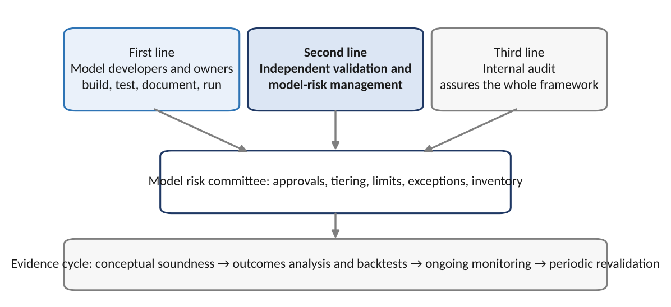
Figure 9.3 — A typical governance structure. The first line builds and uses the model; an independent second line validates and challenges; the third line (audit) assures the framework. A model-risk committee decides approvals, limits, and exceptions, drawing on a continuous evidence cycle.

Inventory and tiering
An organisation cannot govern models it cannot list. A model inventory records every model, its purpose, owner, version, inputs, dependencies, approval date, and validation status. Validation effort is allocated by tier, reflecting how much harm a wrong model could do:
Table 9.2 — Illustrative model tiering
Tier | Criteria | Validation depth | Review frequency
1 — High | Material capital, drives limits or financial reporting, complex or new, many users | Full independent validation: conceptual review, replication, outcomes analysis, stress tests | At least annually, plus on any material change
2 — Medium | Moderate exposure, established methodology, some judgement in use | Focused review: key assumptions, benchmark, backtests | Every 1–2 years
3 — Low | Small exposure, simple, easily replaced, advisory only | Light review: inputs, code check, documentation | Every 2–3 years or on change

What a validation report contains
- Scope and intended use — what the model is for and, explicitly, what it is not for.
- Conceptual soundness — review of theory, assumptions, and the limitations of the data; comparison with alternatives and literature.
- Implementation verification — replication, benchmark and limit tests, code review, and the results of unit and regression tests.
- Outcomes analysis — backtests, out-of-sample and walk-forward results with the multiple-testing count, calibration, and uncertainty bands.
- Sensitivity and stress analysis — parameter stability, input perturbations, scenarios, and behaviour at the boundaries.
- Findings and ratings — each issue with severity, a remediation owner and deadline, and the compensating controls and limits until it is fixed.
- Monitoring plan and triggers — the metrics, thresholds, and escalation path, and conditions for revalidation.
Key idea — Independence is a design requirement, not a courtesy.
The person who built a model is the worst-placed person to find its flaws: they know what it is meant to do and unconsciously test only that. Effective validation therefore needs a reviewer who did not build it, is not rewarded by its success, and reports on a separate line. In small firms where that is impossible, approximate it with rotating peer review, pre-registered tests, and an external reviewer for the largest risks.

9.4 Reproducibility, Engineering Controls and Sanity Tests
Level: Intermediate
A validation result nobody can reproduce is an anecdote. Reproducibility is an engineering problem with a short checklist:
- Version everything — code, configuration, parameters, and the exact data snapshot used; record the git commit and data hash with every reported result.
- Fix random seeds and report results over many seeds where randomness matters (a stochastic optimiser, a bootstrap, a neural net); a result that exists for one seed only is a lucky draw.
- Automate the pipeline — one command should regenerate every table and figure of a validation report; manual steps are where silent errors enter.
- Separate research and production data paths only where unavoidable, and test that they agree.
Finally, a short list of sanity tests catches an astonishing share of backtest errors, because they test the machinery rather than the idea:
Table 9.3 — Backtest sanity tests
Test | How | Expected result | If it fails
Random signal | Replace the signal with random numbers with the same distribution | Sharpe ratio near zero (within standard error) | Leakage or a bug that manufactures returns
Delay test | Lag the signal by one extra period | Performance degrades gradually (fast signals degrade quickly) | No change suggests the signal is not really used; a jump up suggests look-ahead
Reversed signal | Multiply the signal by −1 | Gross return roughly reverses sign (before costs) | Both versions profitable suggests costs or timing are not modelled
Zero-cost check | Run with zero costs and then with realistic costs | Costs reduce return by the amount turnover implies | Unexplained gap means the cost model is wrong
Known-answer test | Buy-and-hold one asset; constant-weight portfolio | Equals the index or hand-computed result | Accounting error in returns, rebalancing, or dividends
Time-shuffle test | Shuffle returns in time (breaking serial structure) | Edge from time-series structure disappears | The result came from something other than the claimed mechanism

Practical Exercise
Build a small validation harness and use it to evaluate a family of candidate strategies where you control the truth. Start with 50 zero-skill strategies, so that every apparent edge is luck, and confirm that your procedures correctly refuse to find one. Then repeat on a strategy built from a real signal and see how much of its edge survives.

Suggested approach
- Simulate daily returns for 50 candidate strategies with no true edge (or generate rules on real data with randomly chosen parameters). Pick the best by in-sample Sharpe ratio and record it.
- Evaluate the selected strategy with walk-forward testing that chooses the strategy on the training window only, with a purge before and an embargo after each test block. Compare with the in-sample figure.
- Put a stationary block-bootstrap confidence interval around the selected strategy's Sharpe ratio, and compute the deflated Sharpe ratio for 50 trials. Explain why the two give different answers from the raw Sharpe.
- Apply a Benjamini–Hochberg correction to the p-values of all 50 strategies; count how many survive. Repeat with 5 of the 50 given a true edge, and measure how many the procedure finds.
- Implement a 99% VaR backtest (Kupiec and Christoffersen) on a simulated GARCH return series using a static and a conditional model, and compare their results and power.
- Run the sanity tests of Table 9.3: random signal, one-period delay, and reversed signal. Write a half-page validation note that states conclusions, caveats, and monitoring triggers.
Skeleton for the practical exercise (tested on synthetic data)
The skeleton below runs end to end on simulated returns. Your exact numbers depend on the random seed and will differ from run to run; the points to check are the relative sizes (the in-sample best versus the walk-forward figure) and that the deflated probability for a zero-skill strategy is far from 1. Requires numpy, pandas and scipy.

import numpy as np, pandas as pd
from scipy.stats import norm, chi2

rng = np.random.default_rng(0)
T, n_trials = 1260, 50
X = rng.normal(0, 0.01, (T, n_trials)) # daily returns of 50 candidate strategies (zero true skill)

def sharpe(r):
return r.mean() / r.std(ddof=1) * np.sqrt(252)

# 1. Walk-forward with purge and embargo: pick the best strategy on the training window only
def walk_forward(X, n_splits=5, min_train=504, purge=10, embargo=5):
edges = np.linspace(min_train, len(X), n_splits + 1).astype(int)
oos = []
for a, b in zip(edges[:-1], edges[1:]):
train = X[: a - purge] # drop days whose labels overlap the test block
best = np.argmax(train.mean(0) / train.std(0))
oos.append(X[a + embargo : b, best]) # skip a few days after the boundary
return np.concatenate(oos)

oos = walk_forward(X)
best_is = (X.mean(0) / X.std(0)).max() * np.sqrt(252)
print(f'best in-sample Sharpe {best_is:.2f} | walk-forward out-of-sample Sharpe {sharpe(oos):.2f}')

# 2. Stationary block bootstrap confidence interval for a Sharpe ratio
def block_bootstrap_ci(r, mean_block=10, B=2000, seed=1):
g = np.random.default_rng(seed); n = len(r); out = np.empty(B)
for b in range(B):
idx = []
while len(idx) < n:
start, length = g.integers(n), g.geometric(1 / mean_block)
idx.extend((start + np.arange(length)) % n)
out[b] = sharpe(r[np.array(idx[:n])])
return np.percentile(out, [2.5, 97.5])

star = X[:, np.argmax(X.mean(0) / X.std(0))]
print('95% bootstrap interval for the selected strategy:', np.round(block_bootstrap_ci(star), 2))

# 3. Deflated Sharpe ratio: probability the true Sharpe is positive after n_trials were tried
def deflated_sharpe(r, n_trials, sr_var):
T = len(r); sr = r.mean() / r.std(ddof=1) # per-period Sharpe
skew, kurt = pd.Series(r).skew(), pd.Series(r).kurt() + 3
gam = 0.5772156649
sr0 = np.sqrt(sr_var) * ((1 - gam) * norm.ppf(1 - 1 / n_trials) + gam * norm.ppf(1 - 1 / (n_trials * np.e)))
z = (sr - sr0) * np.sqrt(T - 1) / np.sqrt(1 - skew * sr + (kurt - 1) / 4 * sr ** 2)
return norm.cdf(z), sr0 * np.sqrt(252)

sr_var = np.var(X.mean(0) / X.std(0))
dsr, sr0 = deflated_sharpe(star, n_trials, sr_var)
print(f'deflated Sharpe probability {dsr:.2f} (benchmark Sharpe from luck alone: {sr0:.2f})')

# 4. Kupiec proportion-of-failures test for a 99% VaR backtest
def kupiec(n_days, n_exceptions, p=0.01):
ph = n_exceptions / n_days
ll0 = (n_days - n_exceptions) * np.log(1 - p) + n_exceptions * np.log(p)
ll1 = (n_days - n_exceptions) * np.log(1 - ph) + n_exceptions * np.log(ph)
lr = -2 * (ll0 - ll1)
return lr, 1 - chi2.cdf(lr, 1)

print('Kupiec, 8 exceptions in 250 days: LR = %.2f, p = %.4f' % kupiec(250, 8))

With the seed above, the best of the 50 zero-skill strategies shows an in-sample Sharpe ratio of about 1.07, the walk-forward out-of-sample Sharpe is about 0.45 (over roughly three years of test data, whose standard error is about 0.6, so it is statistically indistinguishable from zero), the bootstrap interval for the selected strategy is wide (0.16 to 1.96), and the deflated Sharpe probability is 0.41, far from the near-certainty the raw Sharpe ratio suggests. The Kupiec test on 8 exceptions reproduces the 7.73 statistic of Part 6.

Common Beginner Mistakes
- Reporting the in-sample result as the result. The number that matters is out-of-sample, and the out-of-sample set must be used once.
- Tuning on the test set — looking at test performance, changing the model, and testing again turns the test set into a training set.
- Ordinary k-fold cross-validation on time series, which lets the model train on the future, and on overlapping labels, which leak across the fold boundary.
- Ignoring the number of trials. Reporting the best of 100 variants as if it were the only one tried.
- Using final, revised, survivor-only data, and aligning by reference date rather than the date information became known.
- Optimistic costs and unlimited capacity — assuming mid-price fills, no borrow cost, no market impact, and that the strategy can scale without changing prices.
- Judging by the Sharpe ratio alone without a confidence interval, skewness and drawdown analysis, or exposure to known factors.
- Reading failure to reject as proof — a risk model that passes a 250-day backtest has not been shown to be right, only not shown to be wrong.
- Treating a good fit to calibration data as validation of a pricing model, instead of testing it on instruments or dates it was not fitted to.
- Skipping monitoring — assuming that a model that was valid at approval stays valid when data, regimes, and counterparties change.

Advanced Extensions
The following topics build on this document and are introduced by name so you know what to look for next:
- White's Reality Check, Hansen's SPA test and the Model Confidence Set — bootstrap-based tests of whether the best of many models truly beats a benchmark, accounting for the search.
- Harvey–Liu Sharpe haircuts and the t > 3 hurdle — adjusting published factor returns for the many tests that went into the literature.
- Combinatorial purged cross-validation in depth, and path-dependent backtest statistics — distributions of performance across many recombined paths rather than a single path.
- Conformal prediction and distribution-free coverage guarantees — prediction intervals with finite-sample validity under weak assumptions, adapted to time series.
- Bayesian model comparison and hierarchical shrinkage — posterior probabilities for competing models and partial pooling of strategy performance.
- Elicitability, scoring rules and joint VaR–ES validation — the theory of which risk measures can be backtested and with which scores.
- Adversarial and synthetic-data validation — generating realistic synthetic markets (with models fitted to the data) to test strategies where the true answer is known.
- Model-risk quantification — putting a monetary number on model uncertainty (valuation adjustments, model reserves, and capital add-ons for model risk).

Professional Applications
- Systematic strategy research — establishing the evidence standard that a signal must meet before it receives capital, and keeping the trial register that makes deflation possible.
- Independent model validation in banks — reviewing pricing, risk, capital, and stress-testing models under supervisory model-risk guidance.
- Market-risk and regulatory backtesting — VaR and ES exception monitoring, traffic-light reporting, and desk-level approval.
- Allocator and fund due diligence — assessing the reliability of an external manager's track record, including selection and survivorship bias.
- Portfolio construction and risk budgeting — setting drawdown and leverage limits from resampled distributions rather than the single historical path.
- Quant engineering and MLOps — reproducible pipelines, drift monitoring, champion–challenger deployment, and automated sanity tests.

Where to Go Next
This document aimed to give a complete route from the idea of out-of-sample testing to the governance of a model portfolio, and it stopped at awareness depth for the advanced multiple-testing, conformal, and model-risk topics above. The natural next steps depend on your direction. For research, the Optimisation module shows how estimation error amplifies through an optimiser and why shrinkage and robust formulations are validation tools as much as portfolio tools. For macro strategies, the Macroeconomics module covers point-in-time data and regime change in depth. For risk, Risk Metrics extends Part 6 to stress testing, liquidity, and capital.
The most valuable habit to build is to ask, of every result: how many things did I try, what data would have been available at the time, how large is the uncertainty, and what would change my mind? A model that can answer those questions has earned the right to be believed a little.

Appendix A — Formula Sheet
Table A.1 — Key formulas by topic
Topic | Formula | Where used
Bias–variance decomposition | E[(y − f̂)²] = bias² + variance + σ² | 1.3
Standard error of the Sharpe ratio (i.i.d.) | SE(SR) ≈ √[(1 + ½ SR²) / T] (SR and T in years) | 3.4, 4.1
Min. track record for t = 1.96 | T ≈ 1.96² (1 + ½ SR²) / SR² | 4.1
Probability of at least one false positive | 1 − (1 − α)^{m} | 4.2
Bonferroni / Holm | p ≤ α/m ; p₍ᵢ₎ ≤ α / (m − i + 1) | 4.2
Benjamini–Hochberg | Largest i with p₍ᵢ₎ ≤ i α / m; reject ranks 1…i | 4.2
Expected maximum of N null Sharpe ratios | SR₀ = √V · [ (1 − γ) Φ⁻¹(1 − 1/N) + γ Φ⁻¹(1 − 1/(Ne)) ], γ ≈ 0.5772 | 4.3
Deflated Sharpe ratio | Φ[ (SR̂ − SR₀) √(T − 1) / √(1 − γ₃ SR̂ + (γ₄ − 1)/4 · SR̂²) ] | 4.3
AIC / BIC | AIC = 2k − 2 ln L ; BIC = k ln n − 2 ln L | 5.1
CPCV splits and paths | C(N, k) splits ; k/N × C(N, k) paths | 2.4
Net return after costs | μ_{net} = μ_{gross} − turnover × cost per unit traded | 3.3
Kupiec POF statistic | −2 ln[(1−p)^(n−x) p^{x}] + 2 ln[(1−p̂)^(n−x) p̂^{x}] ~ χ²(1) | 6.2
Christoffersen conditional coverage | LR_{CC} = LR_{POF} + LR_{IND} ~ χ²(2) | 6.3
Expected shortfall | ES_{p} = E[−r | r < −VaR_{p}] | 6.4
PIT | u_{t} = F_{t}(r_{t}) ~ Uniform(0, 1) i.i.d. | 6.5
Monte Carlo standard error | SE = σ_{payoff} / √N | 7.2
Mincer–Zarnowitz | y = a + b f + ε ; unbiased if a = 0, b = 1 | 7.4
Diebold–Mariano | DM = d̄ / (s_{d} / √n) | 7.4
Brier score | (1/n) Σ (f_{i} − y_{i})² | 7.5
Information coefficient and fundamental law | IC = Spearman(signal, next return) ; IR ≈ IC √BR | 8.1
Permutation p-value | (1 + #{null ≥ observed}) / (1 + B) | 8.2
Scenario loss | ΔP ≈ Σ Δᵢ Δxᵢ + ½ Σ Γᵢ (Δxᵢ)² | 8.4
Population stability index | Σ (aᵢ − eᵢ) ln(aᵢ / eᵢ) | 8.5
CUSUM | S_{t} = max(0, S_{t−1} + (μ₀ − x_{t})/σ − k); alarm if S_{t} > h | 9.2

Appendix B — Self-Check Questions
Try these without looking back, then check against the sections noted. Answers follow the worked examples in the text.
- A 99% one-day VaR is backtested over 250 days. How many exceptions are expected, and in which Basel zone do 7 exceptions fall? (Answer: 2.5; yellow, with a 0.65 add-on. Section 6.2.)
- The Sharpe ratio of a strategy is 1.0 over 5 years of i.i.d. returns. What is its standard error and an approximate 95% confidence interval? (Answer: √(1.5/5) = 0.55; about −0.07 to 2.07, which includes zero. Section 4.1.)
- You test 20 independent signals at the 5% level. What is the chance at least one is falsely 'significant', and what is the Bonferroni threshold? (Answer: 1 − 0.95²⁰ = 64%; 0.05/20 = 0.0025. Section 4.2.)
- Why does the expected maximum Sharpe ratio of 100 zero-skill strategies over five years exceed 1? (Answer: the standard error of a five-year Sharpe is about 0.45, and the expected maximum of 100 normal draws is about 2.5 standard deviations, giving roughly 1.1. Section 4.3.)
- Why does ordinary k-fold cross-validation overstate performance on a model with 10-day forward labels, and what fixes it? (Answer: training observations whose label windows overlap the test fold leak information; purge them and add an embargo. Section 2.3.)
- How many splits and distinct backtest paths does combinatorial purged cross-validation produce for N = 6 groups with k = 2 test groups? (Answer: 15 splits, 5 paths. Section 2.4.)
- A strategy has gross return 8%, volatility 10%, and trades 10 times its capital a year at 10 basis points per unit traded. What is the net Sharpe ratio? (Answer: cost drag 1%, net return 7%, net Sharpe 0.70 versus 0.80 gross. Section 3.3.)
- A VaR model has 6 exceptions in 250 days, of which two follow another exception the next day. Which test detects the problem? (Answer: Christoffersen independence; Kupiec alone gives p = 0.059 and passes. Section 6.3.)
- A Monte Carlo price uses 10,000 paths with payoff standard deviation 14.7. What is the standard error, and how many paths halve it? (Answer: 0.147; four times as many, 40,000. Section 7.2.)
- Forecast probabilities 0.9, 0.8, 0.3, 0.6, 0.2 meet outcomes 1, 1, 0, 0, 0. What is the Brier score? (Answer: 0.108. Section 7.5.)
- A signal has IC = 0.05 on 250 independent bets a year. What information ratio does the fundamental law imply? (Answer: 0.05 × √250 = 0.79. Section 8.1.)
- A feature's distribution has shifted with PSI = 0.136. What does that indicate and what would you do? (Answer: moderate shift; investigate whether outcomes or accuracy are affected and tighten monitoring. Section 8.5.)
- After one year live, a strategy with a backtested Sharpe of 1.0 has realised 0.2. Is it broken? (Answer: no evidence either way; the one-year standard error is about 1.2, and about 3.8 years are needed to tell a Sharpe of 1 from 0. Section 9.1.)

